| **CLOUD COMPUTING LAB** | | | |
| --- | --- | --- | --- |
| **Course code:** | **IPCC22IS72** | **Credits:** | **04** |
| **Prerequisites:** | **Computer Networks, Big Data Analytics** | **CIE Marks:** | **50** |
| **Teaching Hours / Week (L : T : P)** | **3 : 0 : 2** | **SEE Marks:** | **50** |
| **Total Hours:** | **52 [L: Lecture 40 + P: Practical 12]** | **Exam Hours:** | **03** |

|  |  |  |  |  |  |  |  |  |  |  |  |  |  |  |  |  |  |  |  |  |
| --- | --- | --- | --- | --- | --- | --- | --- | --- | --- | --- | --- | --- | --- | --- | --- | --- | --- | --- | --- | --- |
| |  |  | | --- | --- | | **Course Objectives:** | | | **1.** | Introduce the rationale behind the cloud computing revolution and the business drivers | | **2.** | Introduce various models of cloud computing | | **3.** | Introduction on how to design cloud native applications, the necessary tools and the design tradeoffs. | | **4.** | Realize the importance of Cloud Virtualization, Abstraction`s and Enabling Technologies and cloud security |  |  |  | | --- | --- | | **Course Outcomes: At the end of the course, student will be able to:** | | | **CO1** | Understand and analyze various cloud computing platforms and service provider | | **CO2** | Illustrate various virtualization concepts. | | **CO3** | Identify the architecture, infrastructure and delivery models of cloud computing | | **CO4** | Analyze various platforms for development of cloud applications | |

| **Mapping of Course outcomes to Program outcomes:** | | | | | | | | | | | | | | | | |
| --- | --- | --- | --- | --- | --- | --- | --- | --- | --- | --- | --- | --- | --- | --- | --- | --- |
|  | **PO1** | **PO2** | **PO3** | **PO4** | **PO5** | **PO6** | **PO7** | **PO8** | **PO9** | **PO10** | **PO11** | **PO12** | **PSO1** | **PSO2** | **PSO3** |
| **CO1** | 2 | 3 | 1 | - | 1 | 1 | - | 1 | 1 | - | - | 1 | 1 | - | 1 |
| **CO2** | 3 | 2 | 2 | - | 1 | 1 | - | 1 | 1 | - | - | 1 | 1 | - | 1 |
| **CO3** | 2 | 2 | 2 |  | 1 | 1 | - | 1 | 1 | - | - | 1 | 1 | - | 1 |
| **CO4** | 3 | 2 | 2 | - | 2 | 2 | - | 2 | 2 | - | - | 2 | 1 | - | 1 |

| **Expt.**  **No** | **Part A: Lab Experiments**  **Contents of the experiment** | **Hours** |
| --- | --- | --- |
| **1.** | Creation of AWS account. Exploring commands in AWS CloudShell and the AWS Cloud9 IDE | **2** |
| **2.** | Working on Amazon Dynamo DB by creating tables, populating the table data using JSON and PartiQL. To execute queries such as replace student USN, Set item, drop item and delete table. | **2** |
| **3.** | Develop and deploy a REST APIs with Amazon API Gateway using HTTP methods and Lambda functions. | **2** |
| **4.** | Create an EC2 instance and migrate a web application to Docker Container. | **2** |
| **5.** | Caching Application Data with ElastiCache, Caching with Amazon CloudFront, Caching Strategies. | **2** |
| **Part B: Mini Project**  Each student has to carry out a mini project on the problem identified individually or in a group.  The project developed will be reviewed by internal faculties during the semester. At the completion of a project the student will submit a project report, which will be evaluated by duly appointed examiner(s).  1. Create their private cloud for the institute using the available resources.  2. Apply security concepts to secure a private cloud.  3. Implement efficient load balancing.  4. Compare various virtualization technologies with given resource.  5. Create cloud applications such as messenger, photo editing website, your own social media and any anomaly detection alarm etc.  Note: Evaluators must check if students have used appropriate cloud computing tools for their projects | | |

**PROGRAM 1: Exploring AWS CloudShell and the AWS Cloud9 IDE**

**Steps for creating CloudShell Step 1:** Login to AWS Account

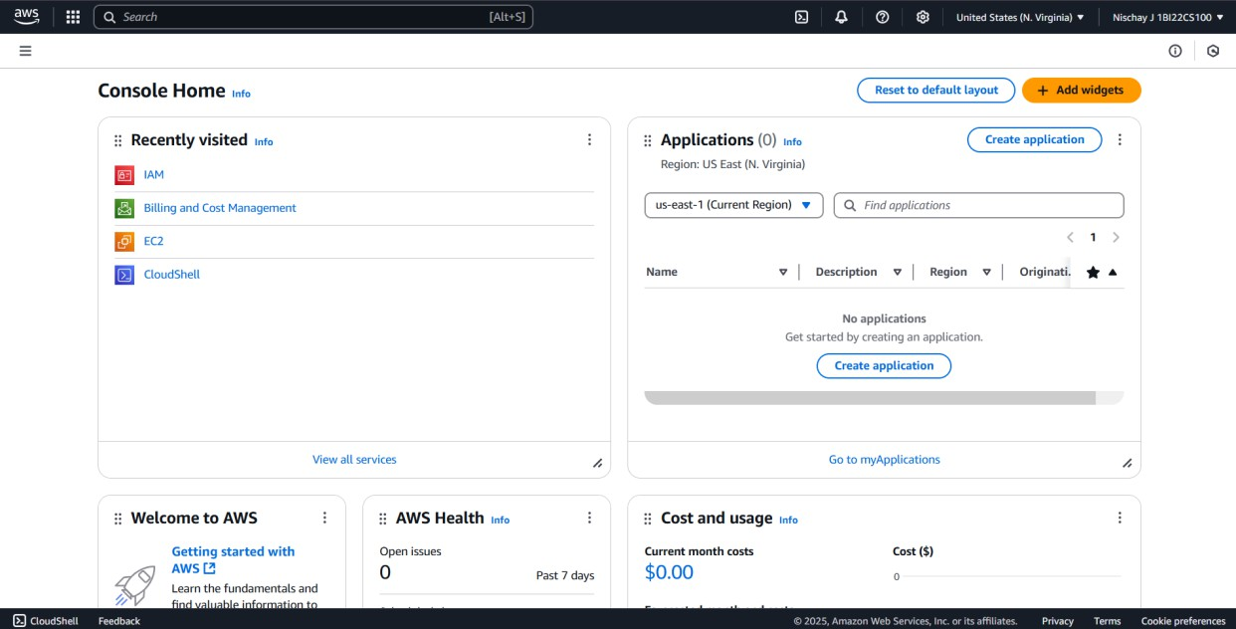

**Step 2:** Open CloudShell

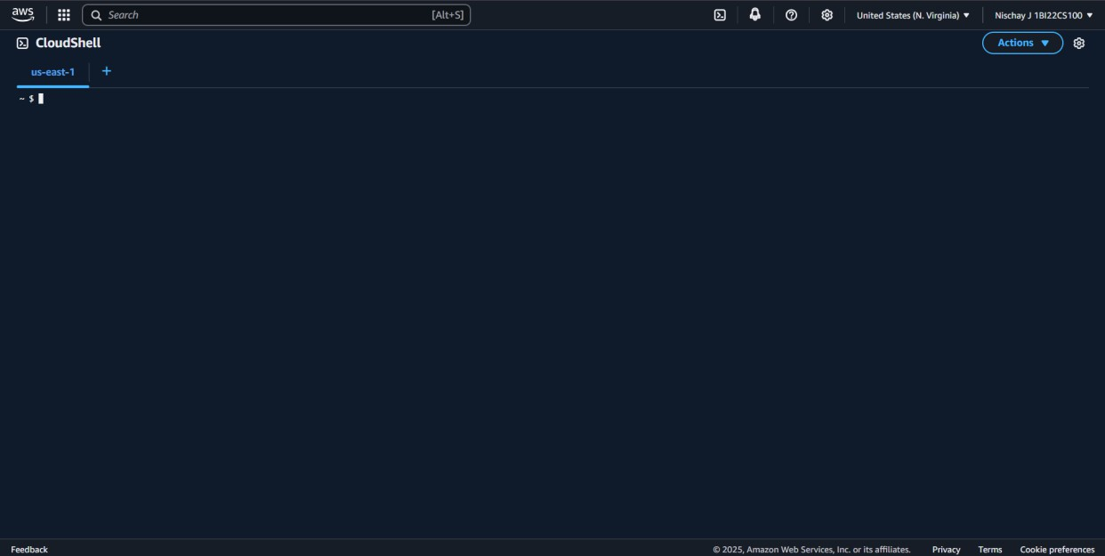

**Step 3:** Execute shell commands in the terminal

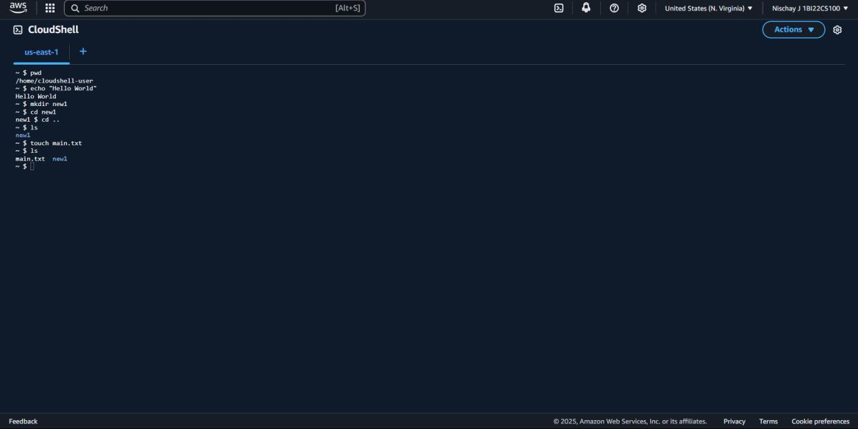

**Step 4:** Choose Download file from Actions dropdown menu

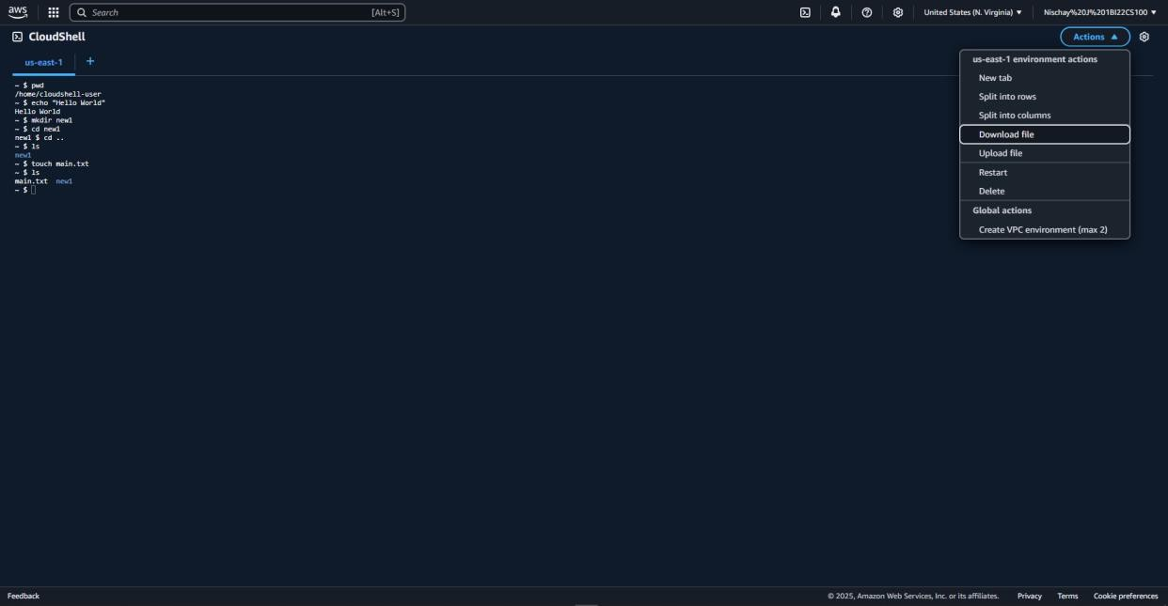

**Step 5:** Provide the path to the file created (demo.txt)

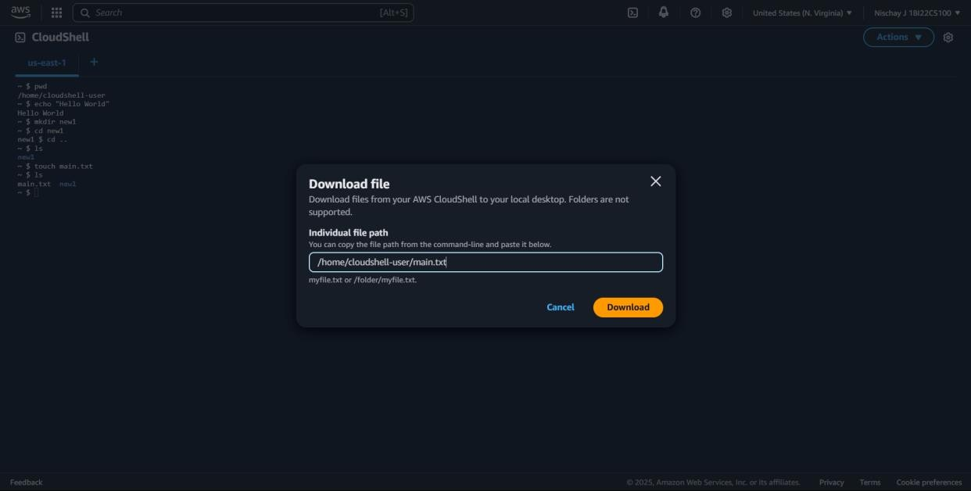

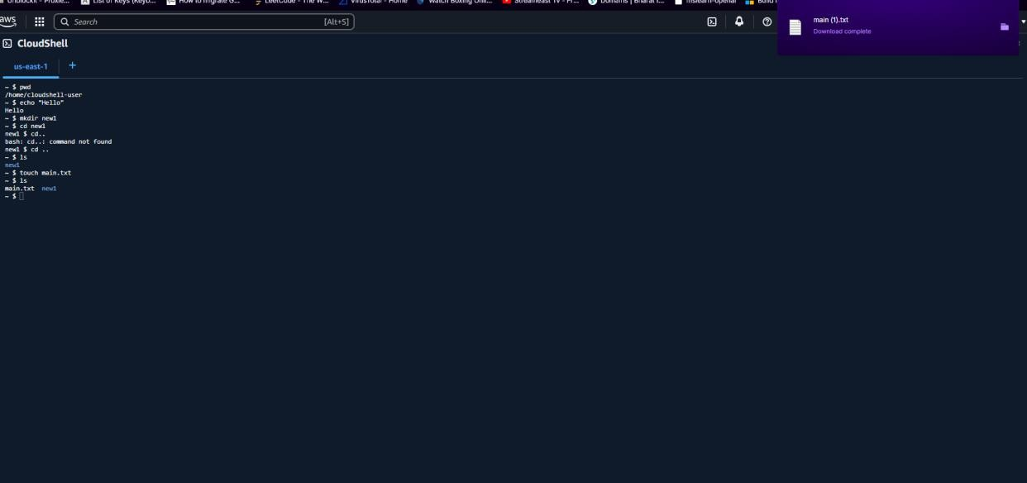**Step 6:** An empty file “demo.txt” is downloaded

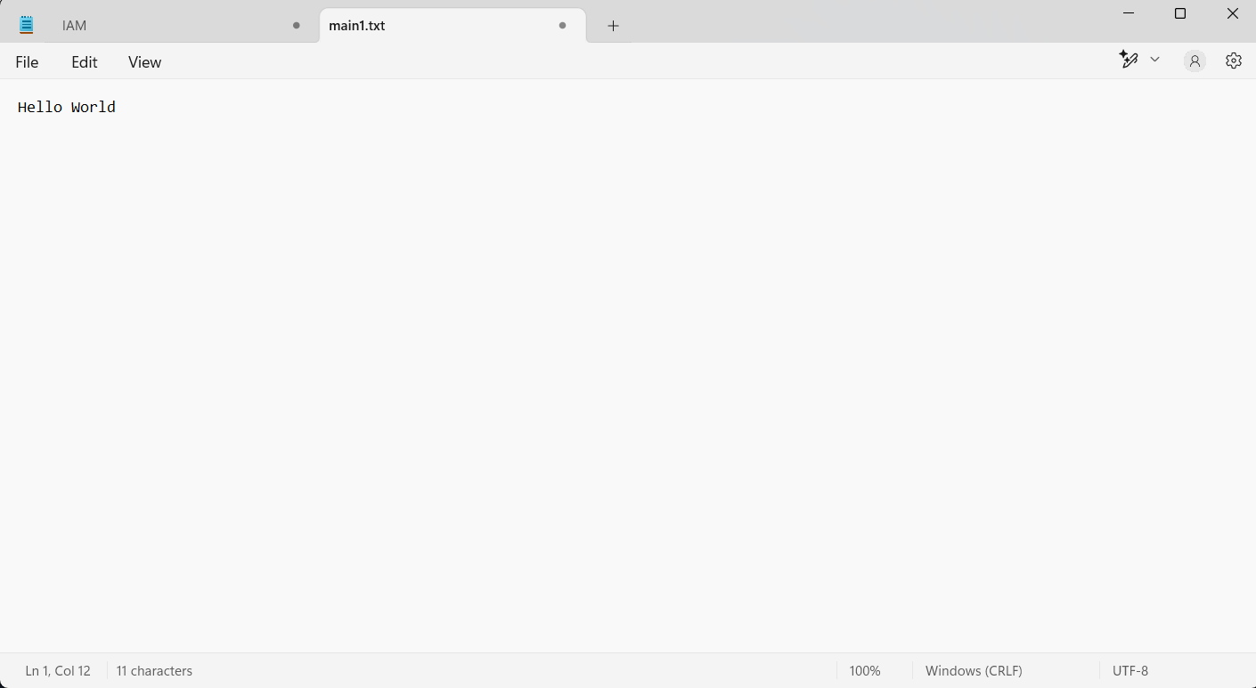**Step 7:** Add content in the downloaded file(demo.txt) and save

**Step 8:** Execute ‘rm’ command. To upload file, click on Upload file option from the Actions dropdown menu

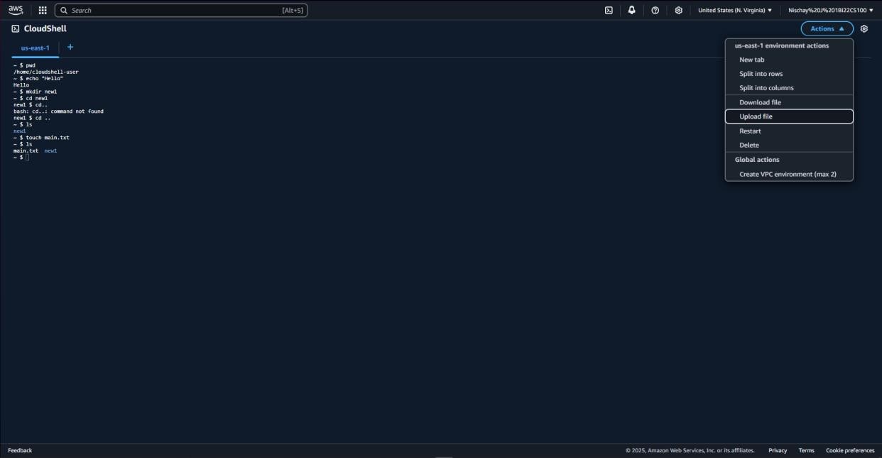

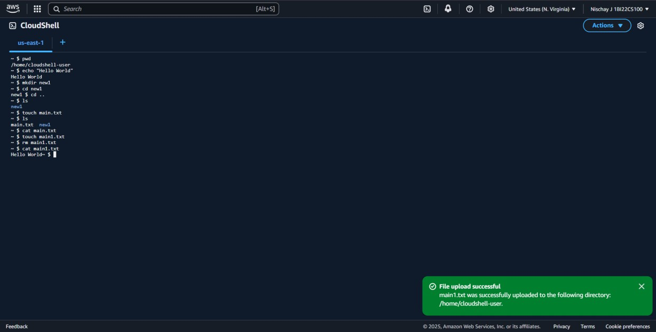**Step 9:** Upload demo.txt file

**Step 10:** Once uploaded successfully, check the contents of demo.txt using the ‘cat’ command

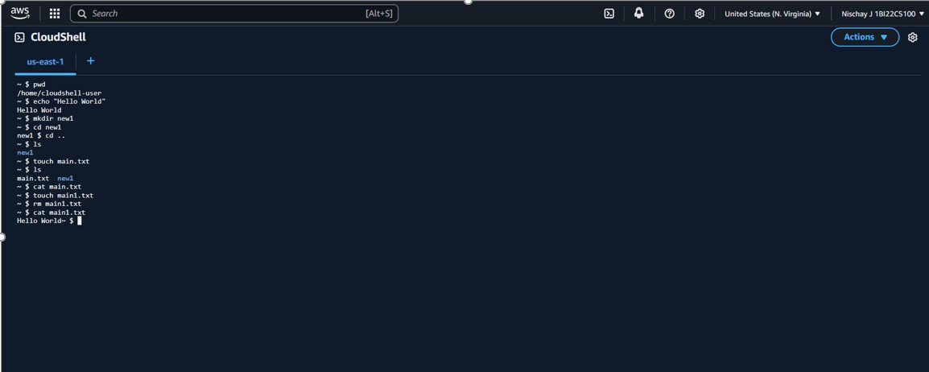

**Steps for creating VPC Environment**

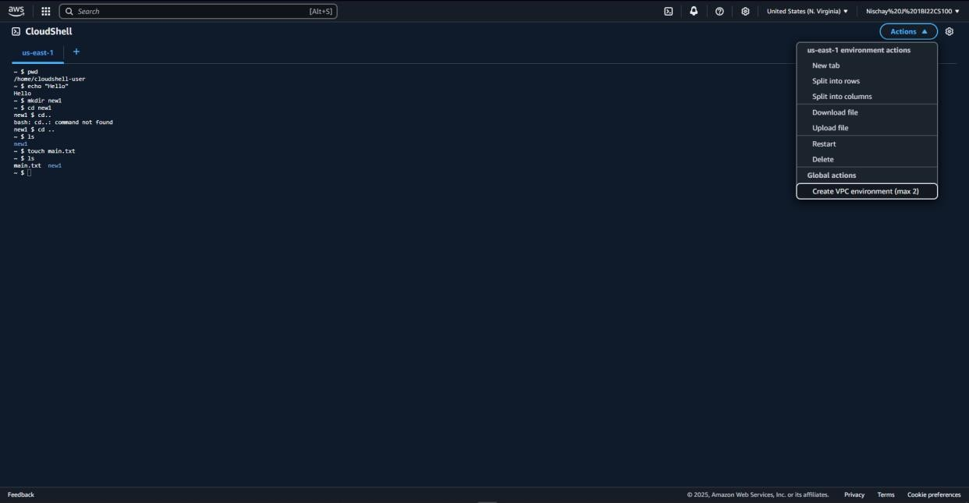**Step 1:** From the Actions menu choose ‘Create VPC environment’

**Step 2:** Give a VPC name and choose VPC, Subnet and the default security group. Click on Create

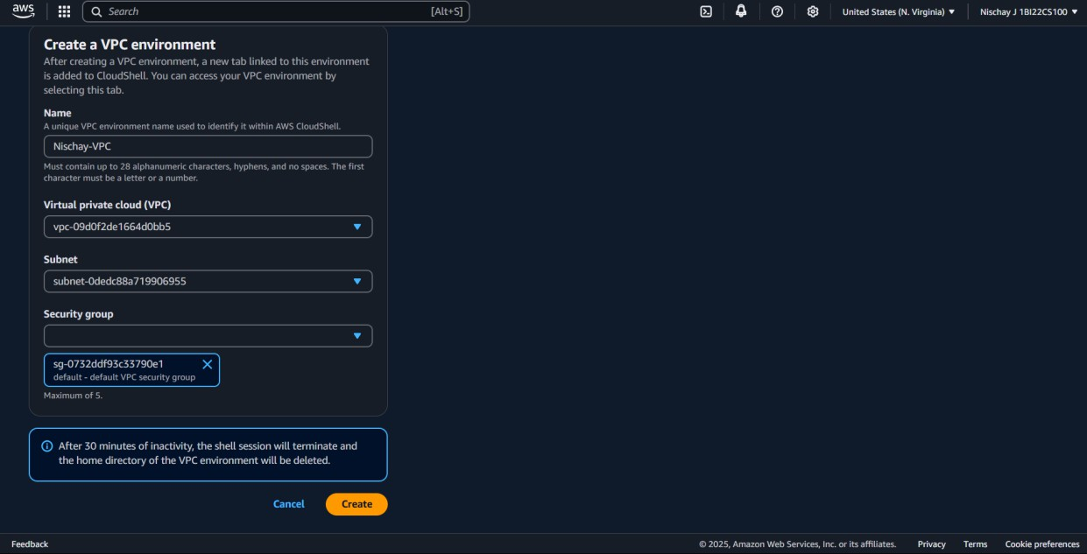

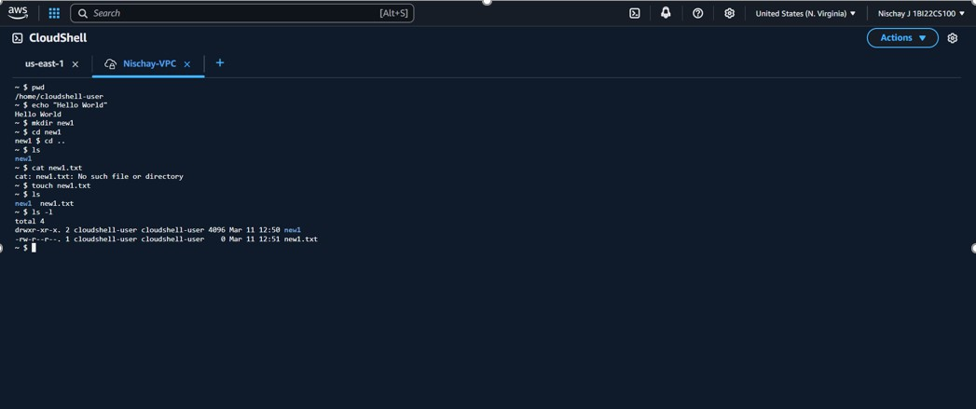**Step 3:** Execute the same commands as of CloudShell in the VPC window except for download and upload file options

**Step 4:** Once all the commands are executed delete the VPC

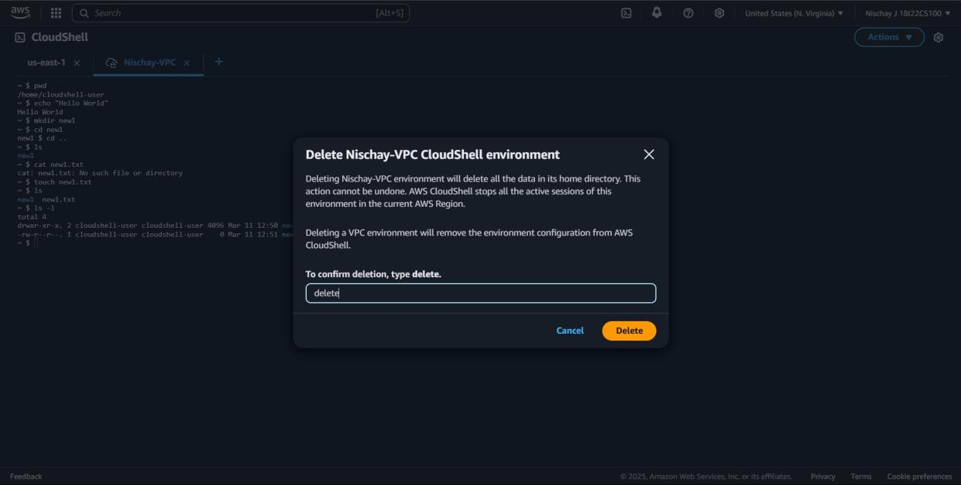

**Step 5:** Also delete the CloudShell once the commands are executed

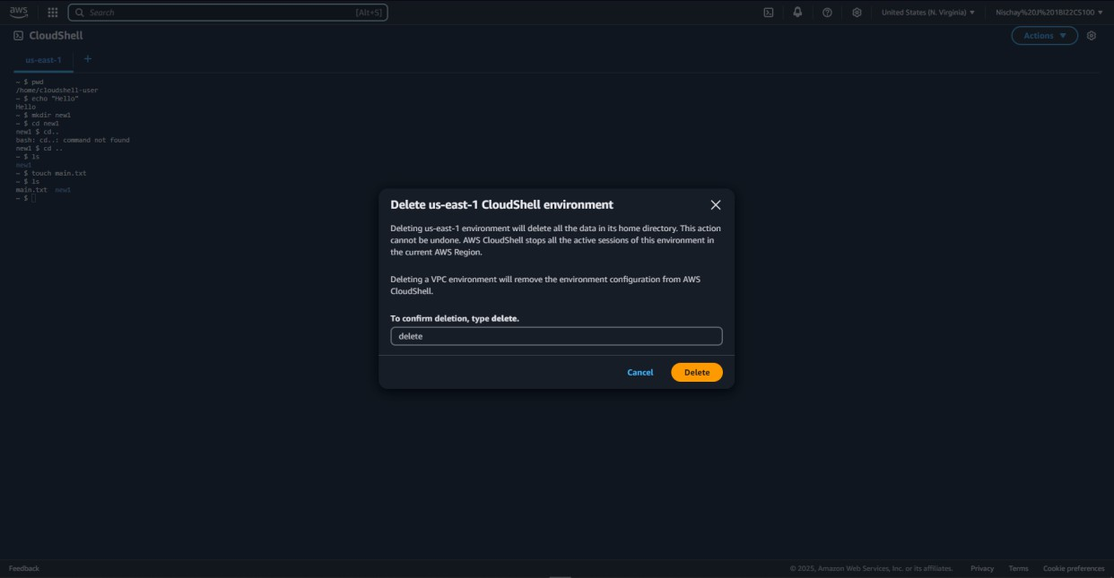

**Steps to create EC2 instance**

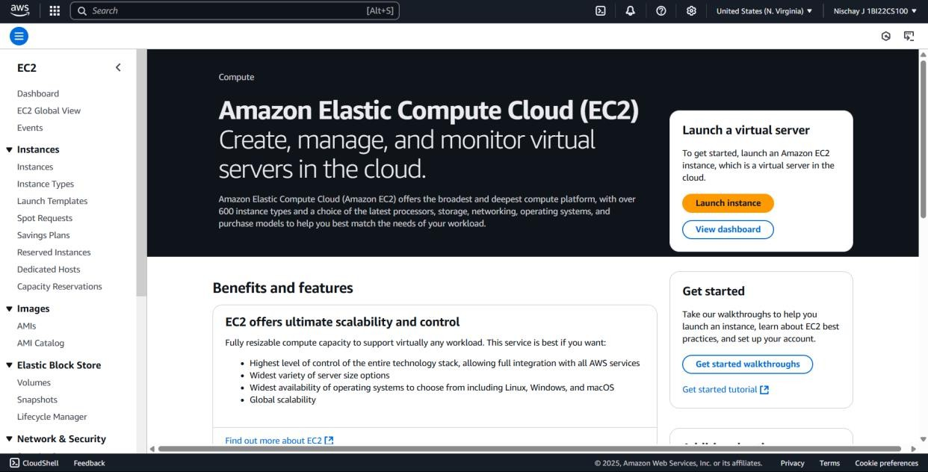**Step 1:** Open EC2 in AWS Console and click on Launch Instance

**Step 2:** Name the instance and proceed below

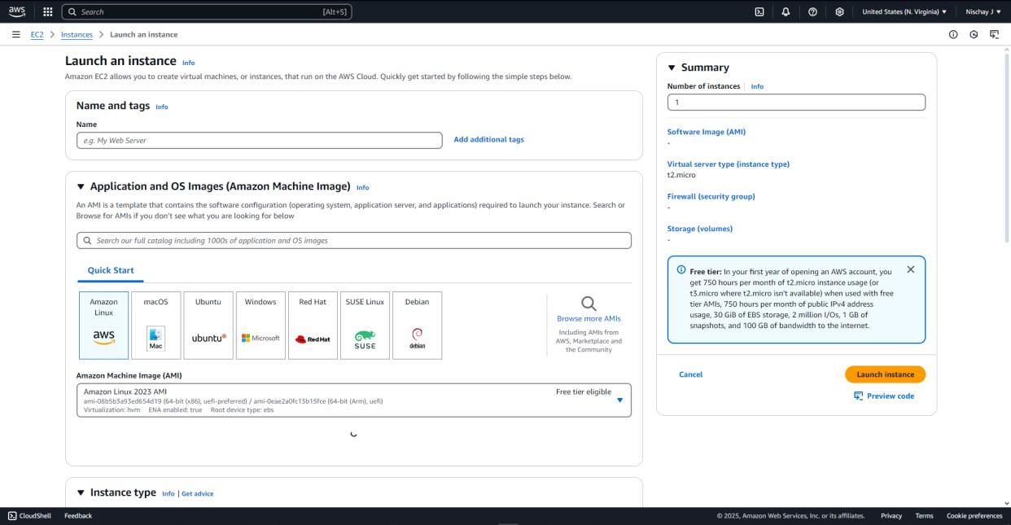

**Step 3:** Click on create new key pair .Create a new key pair by providing a name

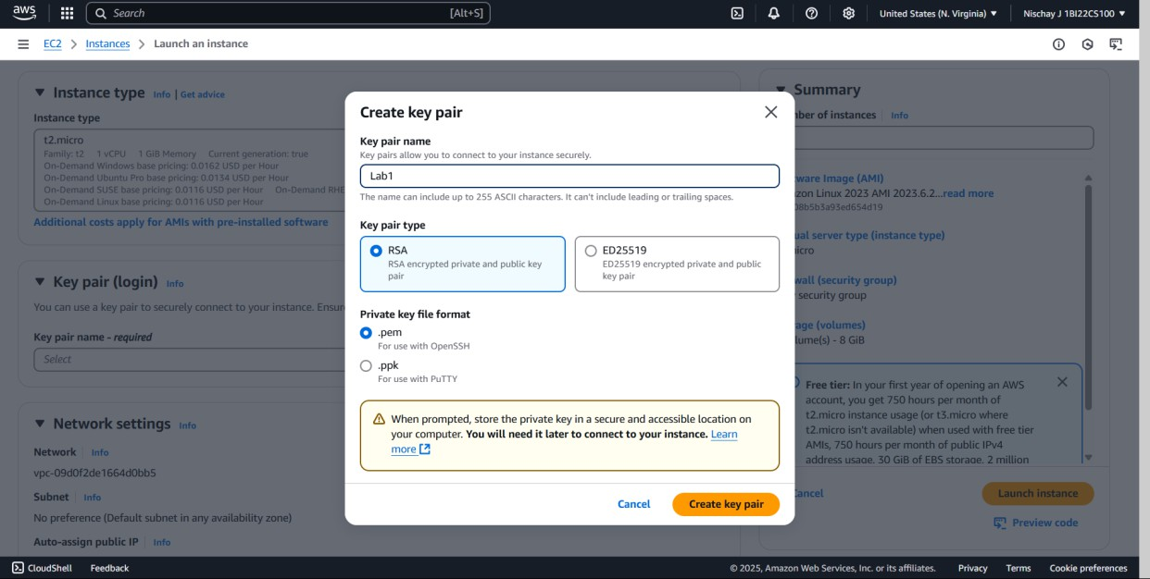

**Step 4:** Keep the default options for the rest and click on Launch Instance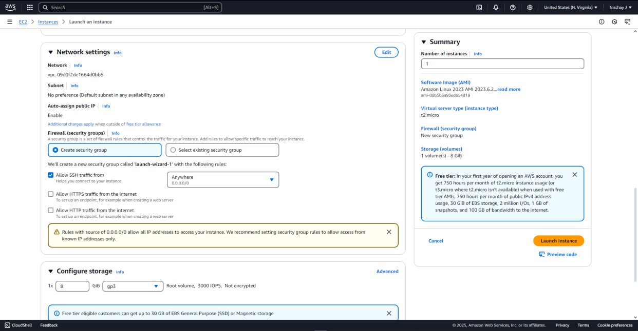

**Step 5:** Confirmation of the launch of our new instance

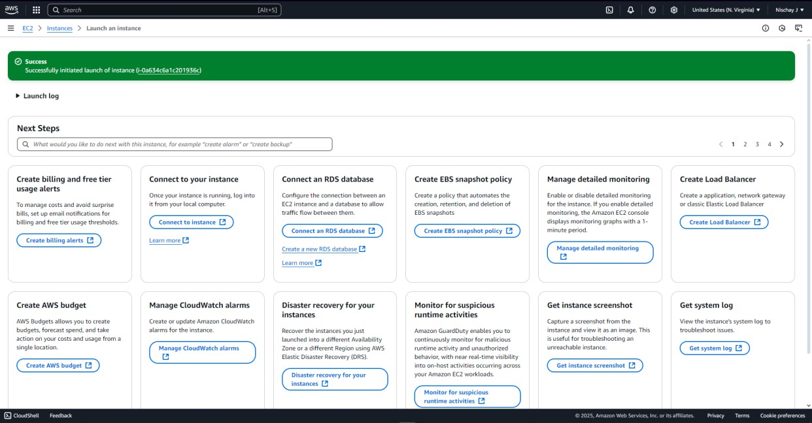

**Step 6:** Click on Instances. It displays the instances that are running. Click on Instance ID to know about a particular instance.

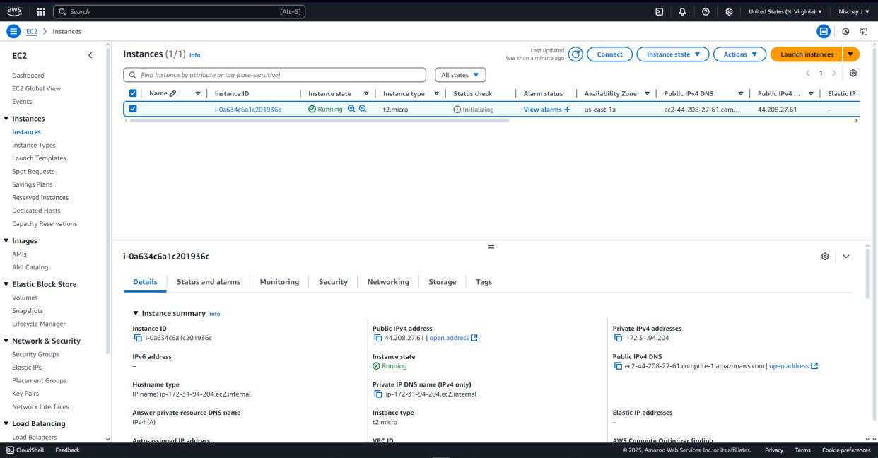

**Step 7:** Click on the Connect option on the top-right to connect to an instance

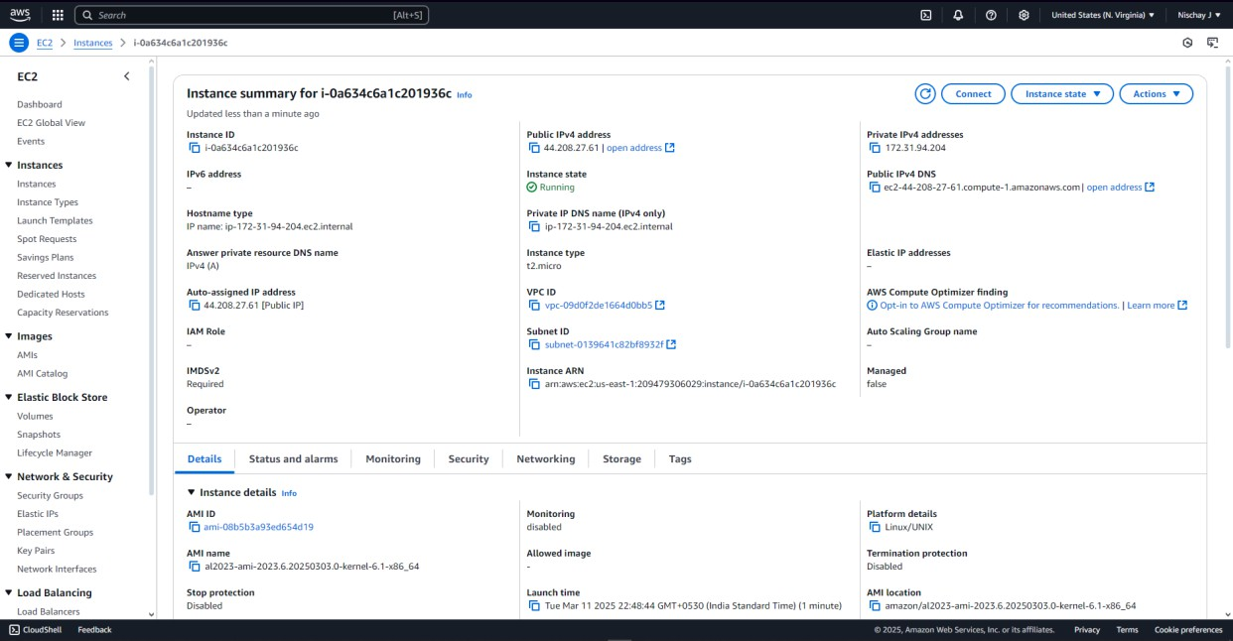

**Step 8:** Keep the default options and click on Connect

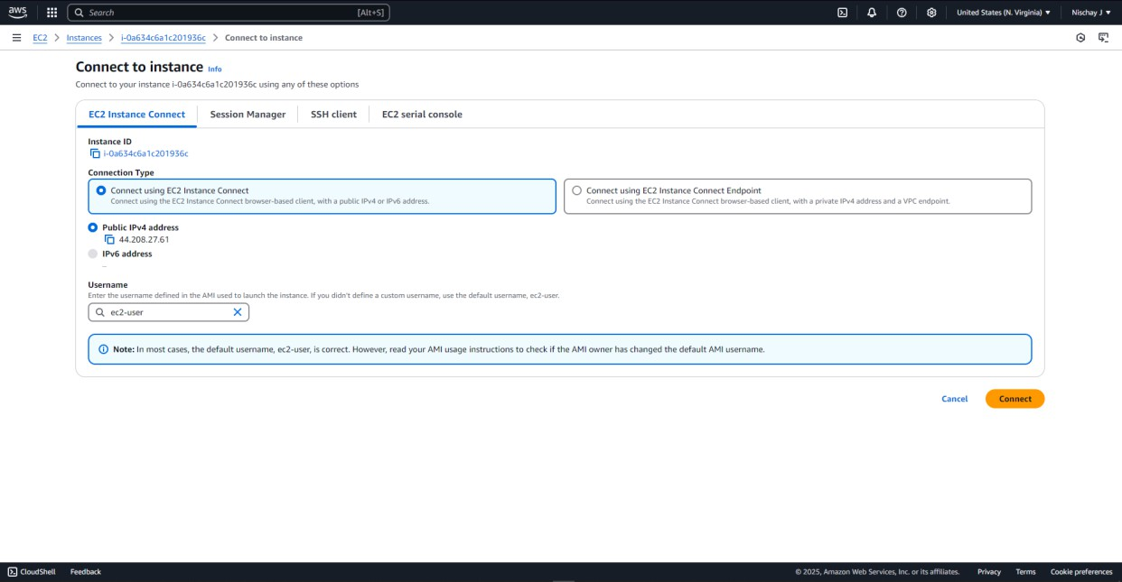

**Step 9:** An Amazon-Linux terminal is displayed

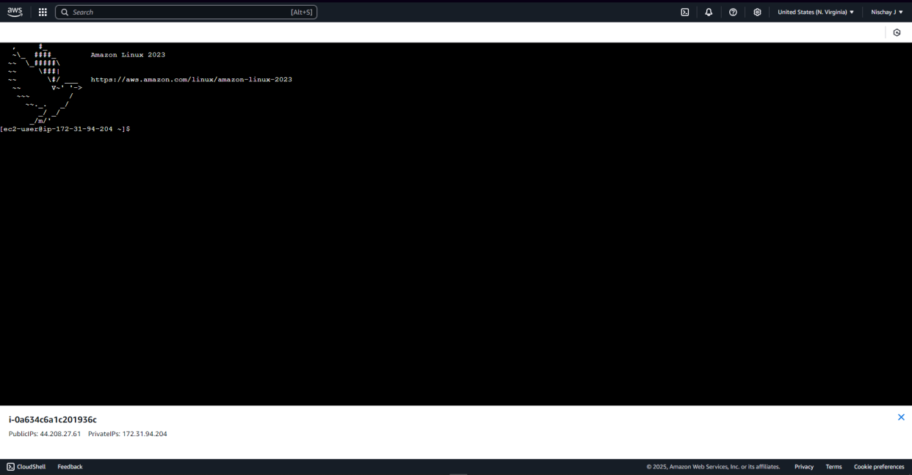

**Step 10:** Execute the commands executed in VPC in this terminal

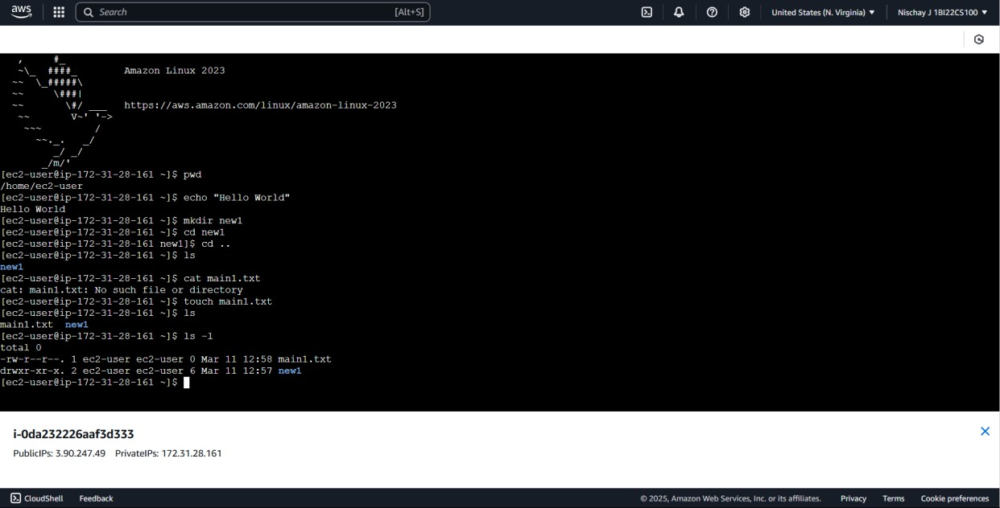

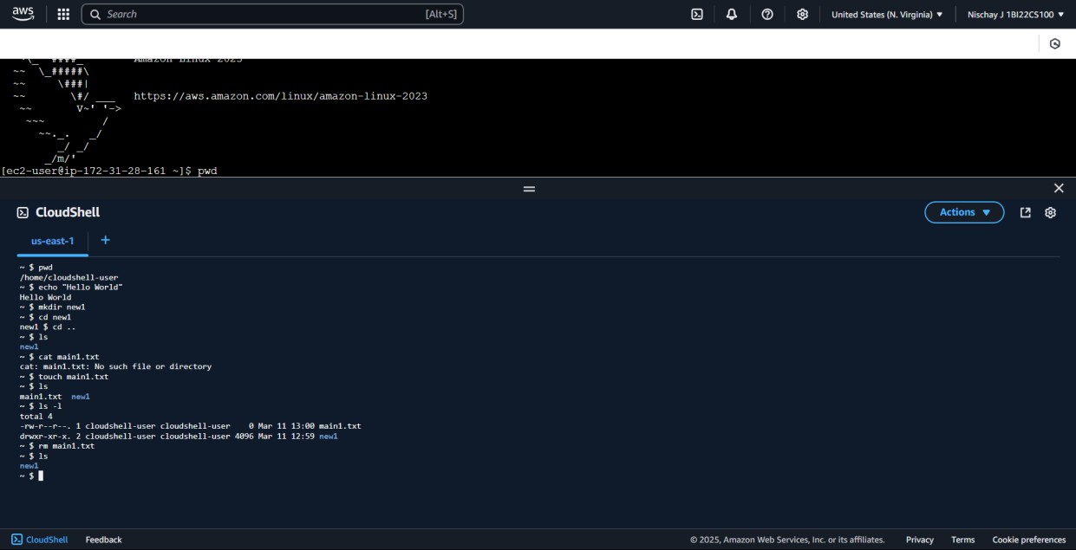**Step 11:** The CloudShell button on the bottom-left corner can be clicked to open a shell terminal. We can execute commands and create VPC here

**Step 12:** Delete the EC2 instance after execution by clicking on Terminate(delete) instance

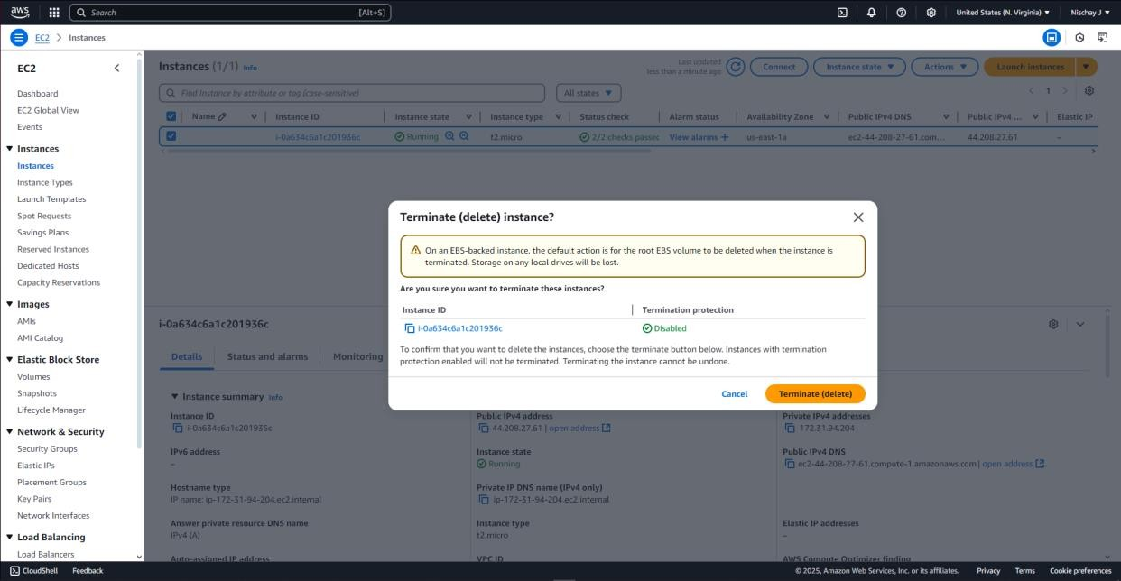

**Step 13:** Indicates the successful termination of the instance. Also delete the corresponding key pair and Security groups associated with this instance

User can sign-out of the AWS account after these steps.

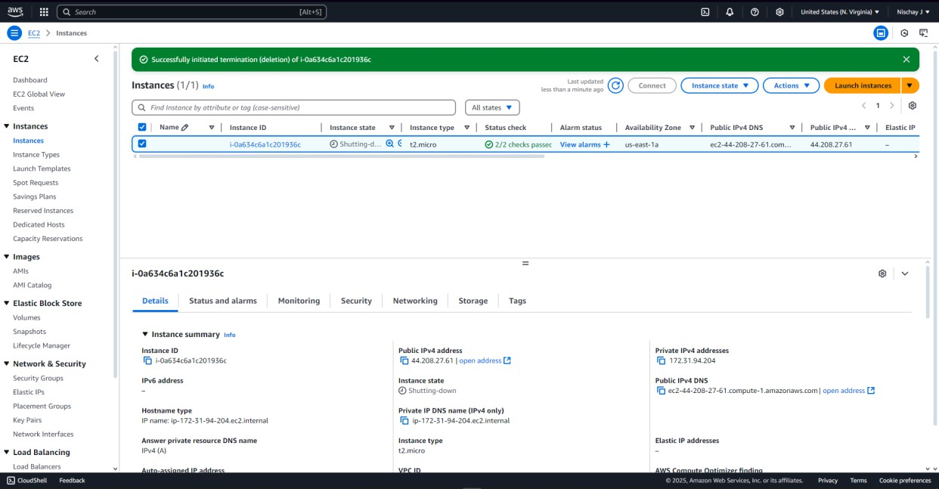

**PROGRAM 2: Working with DynamoDB which makes use of PartiQL**

**Steps for creation of DynamoDB User**

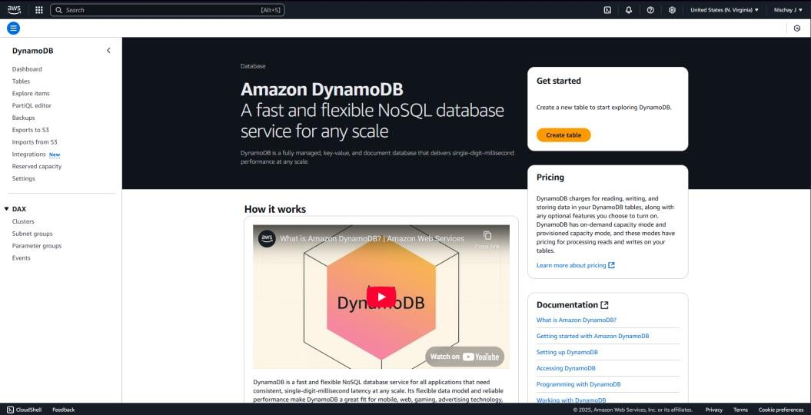**Step 1:** Login to AWS account. Search for DynamoDB

**Step 2:** Select “Tables” from the left panel and click on “Create Table”

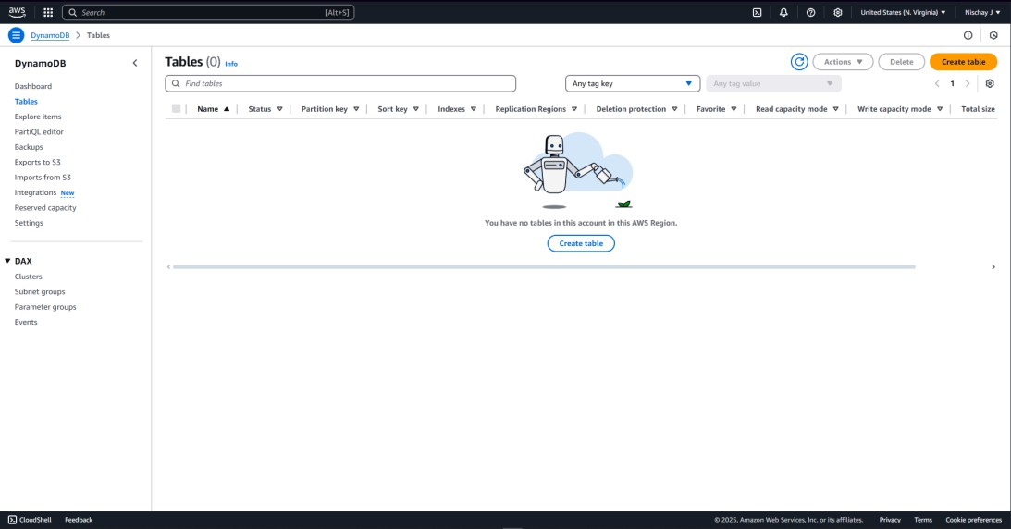

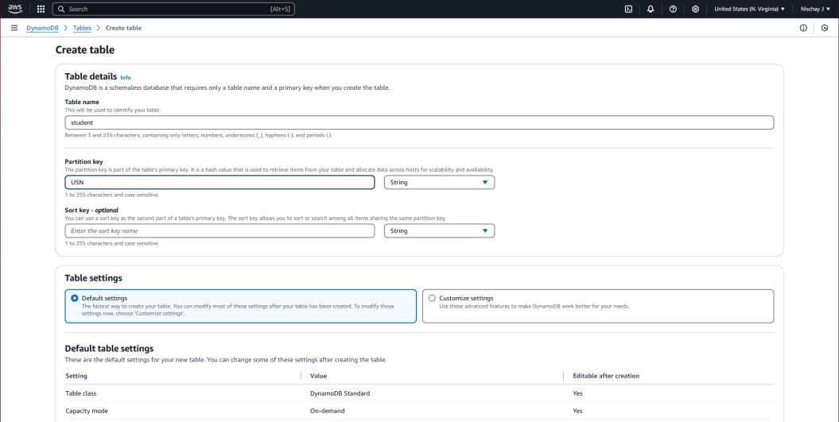**Step 3:** Enter the details by giving the table name as “student” and partition key as “USN”

**Step 4:** Select “Customize Settings” under Table Settings and select “DynamoDB standard- IA” under Table Class

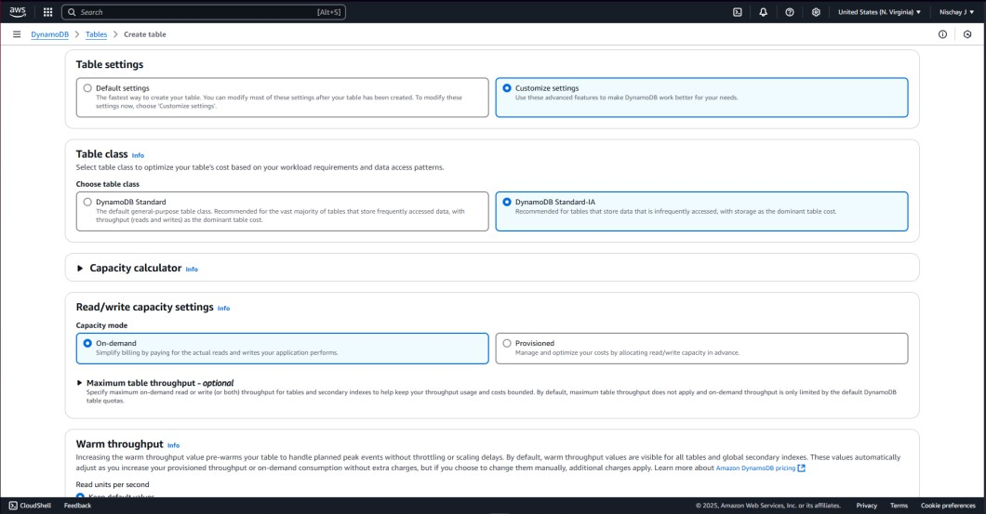

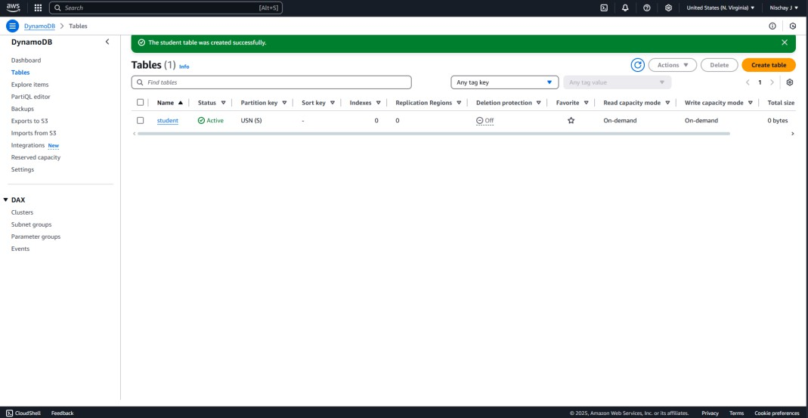**Step 5:** Click on “Create Table”. Once the table is created successfully click on the highlighted table link

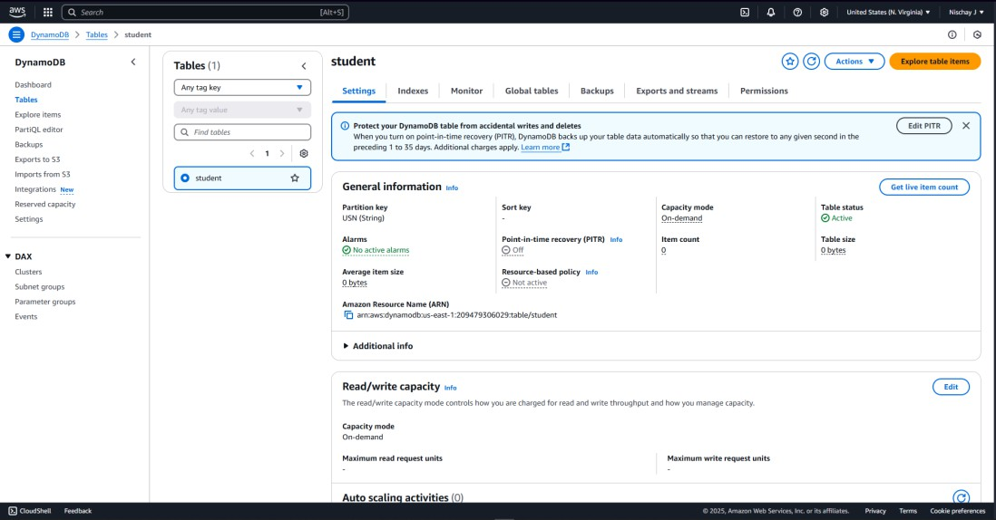**Step 6:** Click on the “Explore table items”

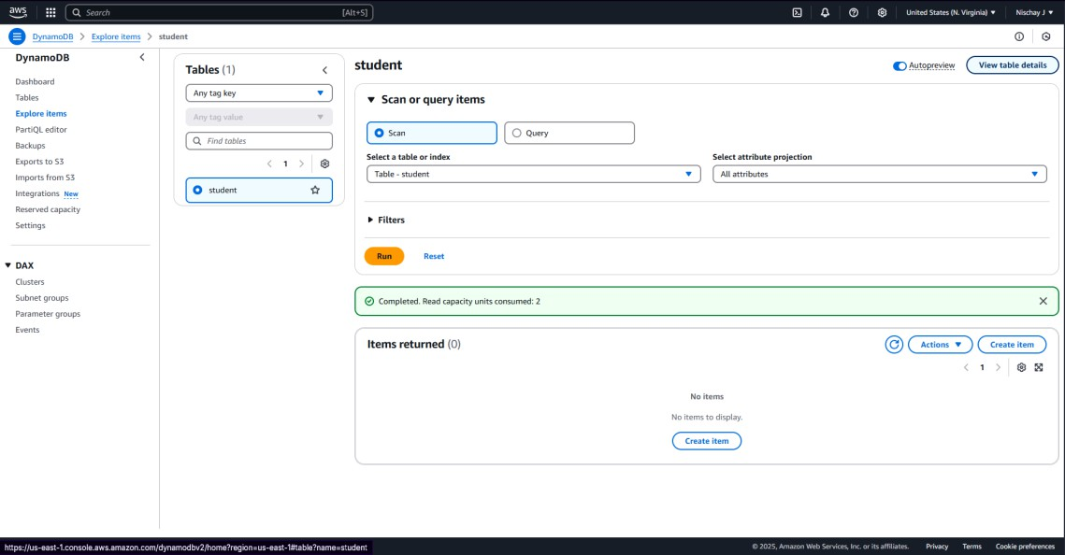**Step 7:** Click on “Create item”

**Step 8:** Create a new item by filling up the Attributes such as Name, Dept, Sem, Sec, Batch. And click on “Create item”

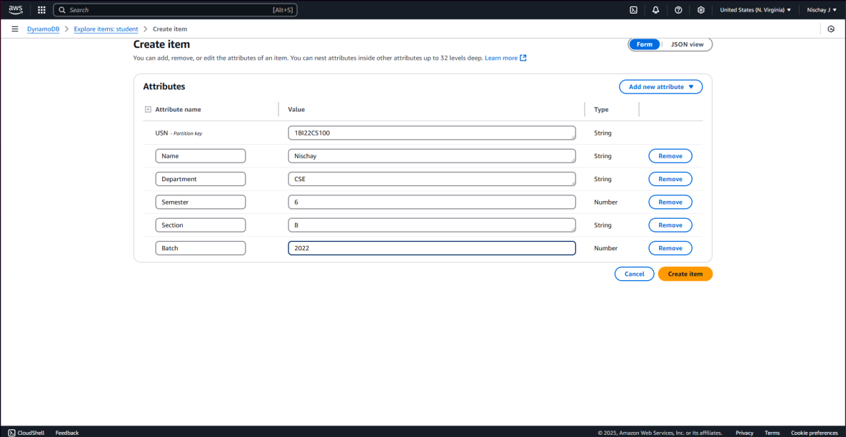

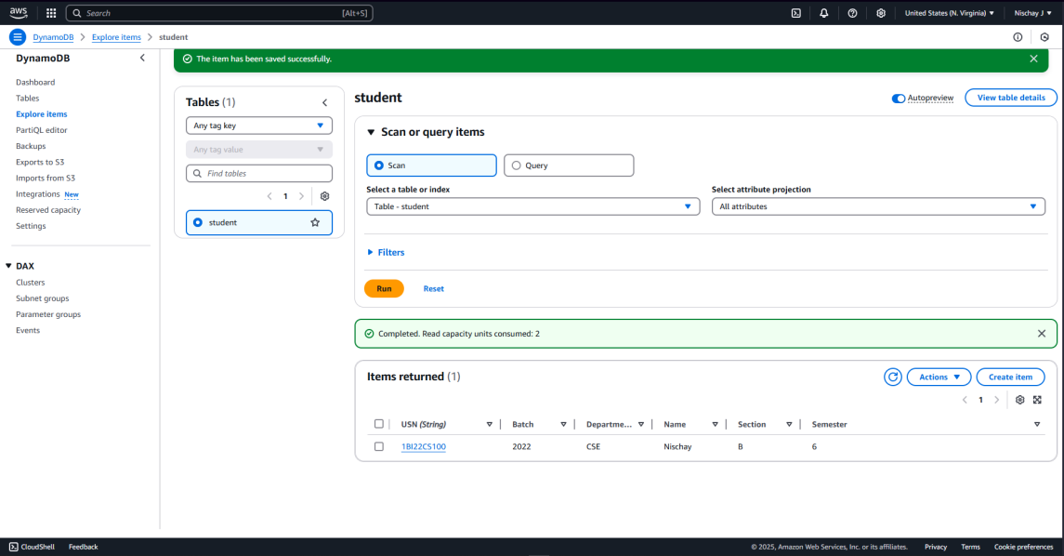**Step 9**: The Table shows the item created

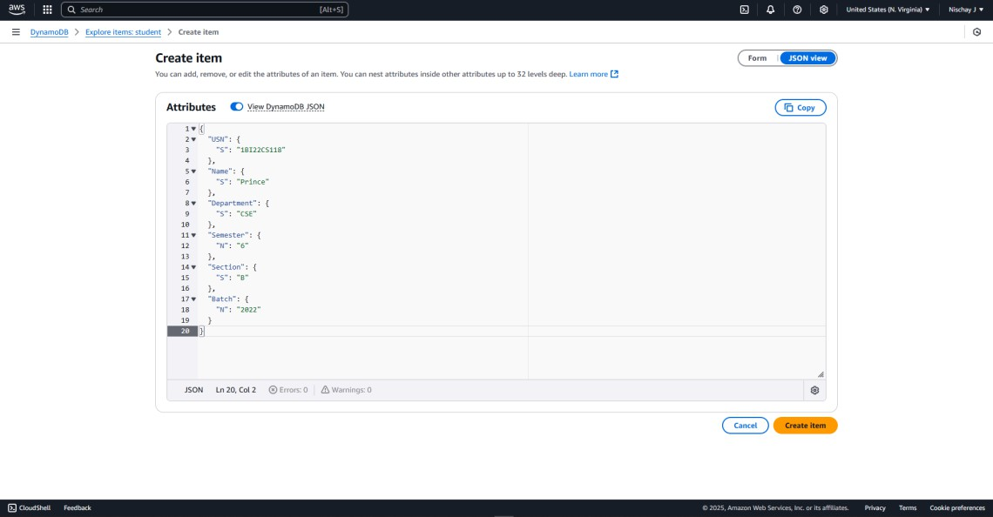**Step 10:** Create another item using JSON view (Java Script Object Notation)

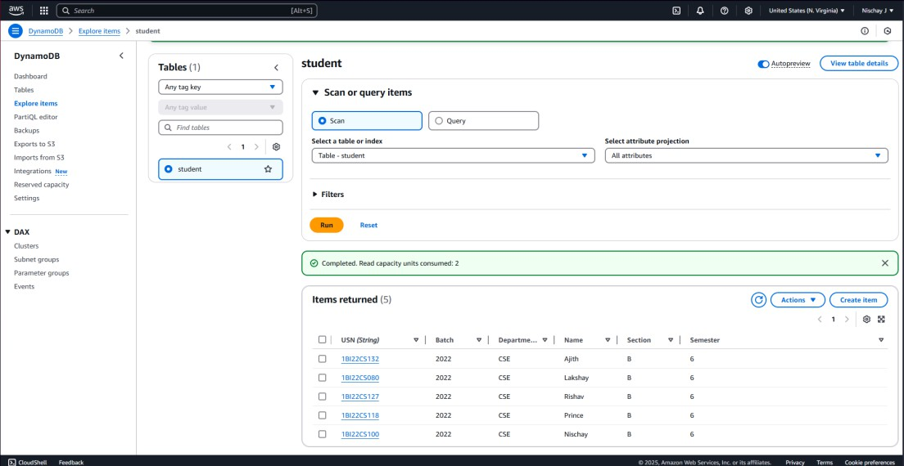**Step 11:** Create a total of 4-5 items using Form or JSON view

**Step 12:** Click on the “PartiQL editor” on the left panel. Click on the 3 dots next to the students and it will provide ways in the table can be viewed

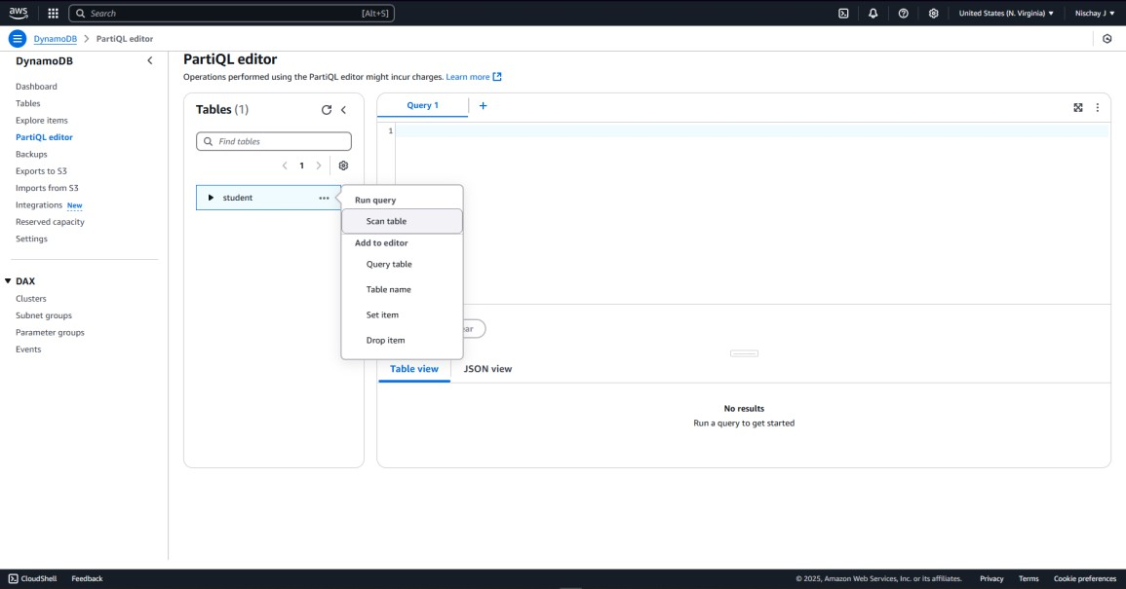

**Step 13:** If we click on “scan table” the whole table will be visible

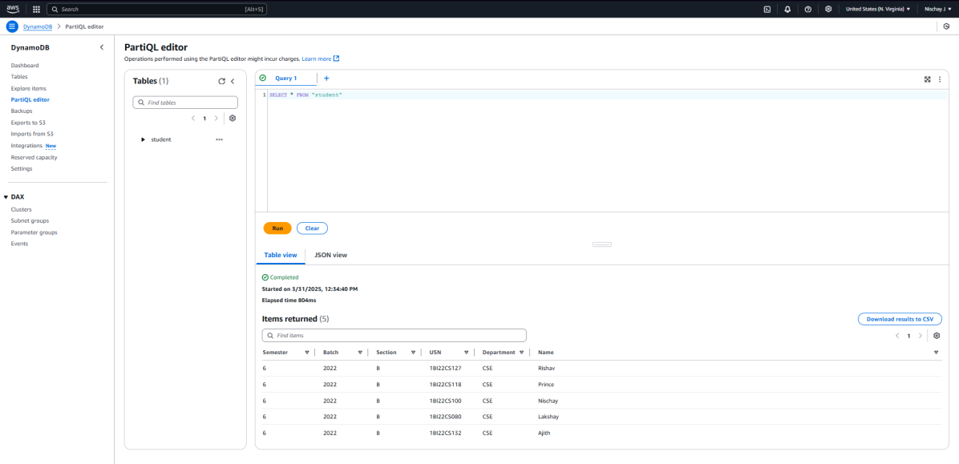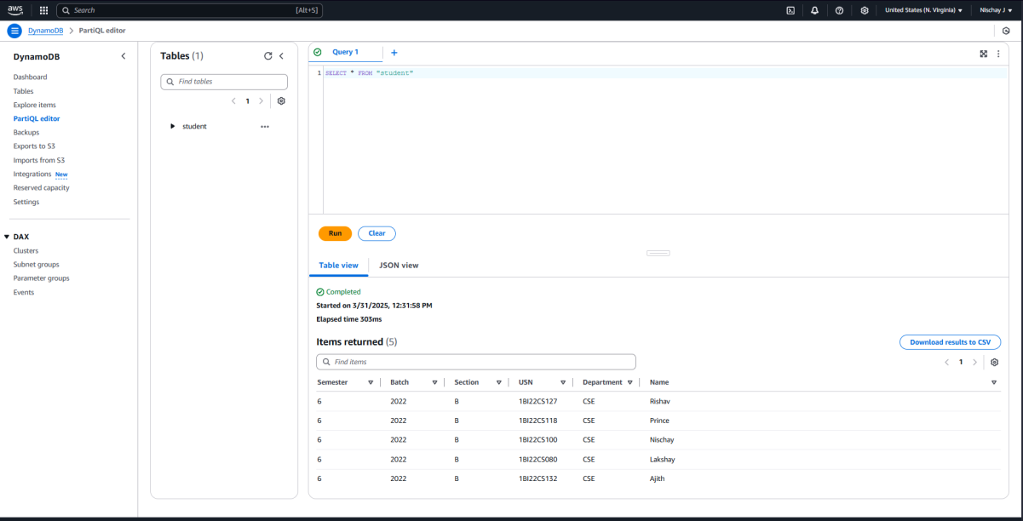

**Step 14:** Click on “Query table” -> Clear ->Replace the USN value with any of the given values

->Run

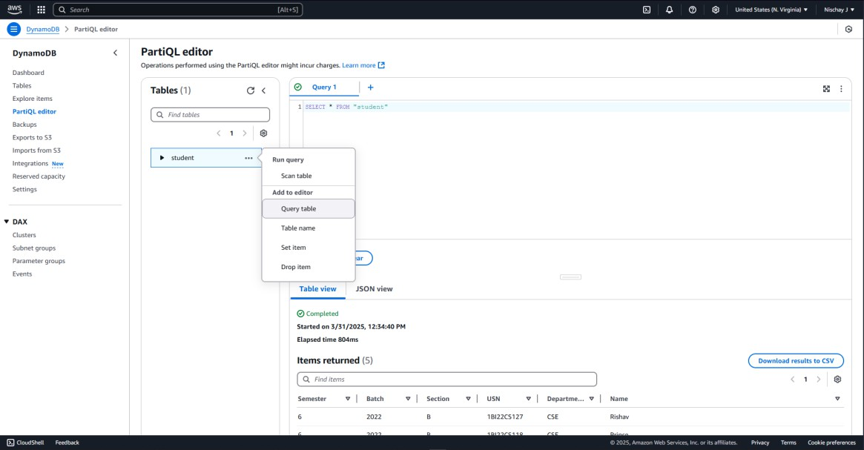

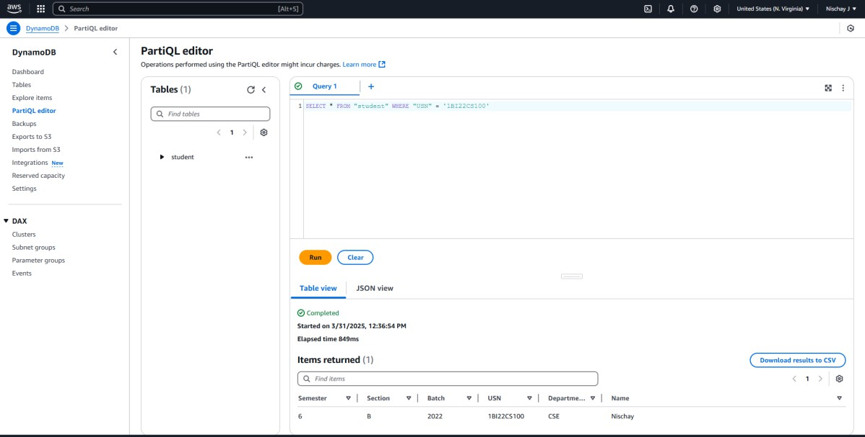

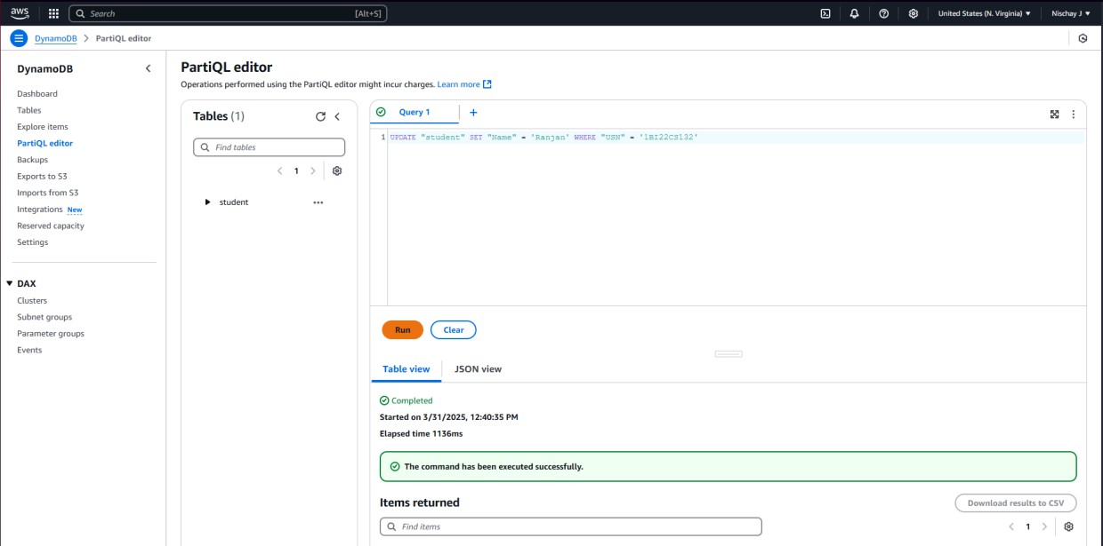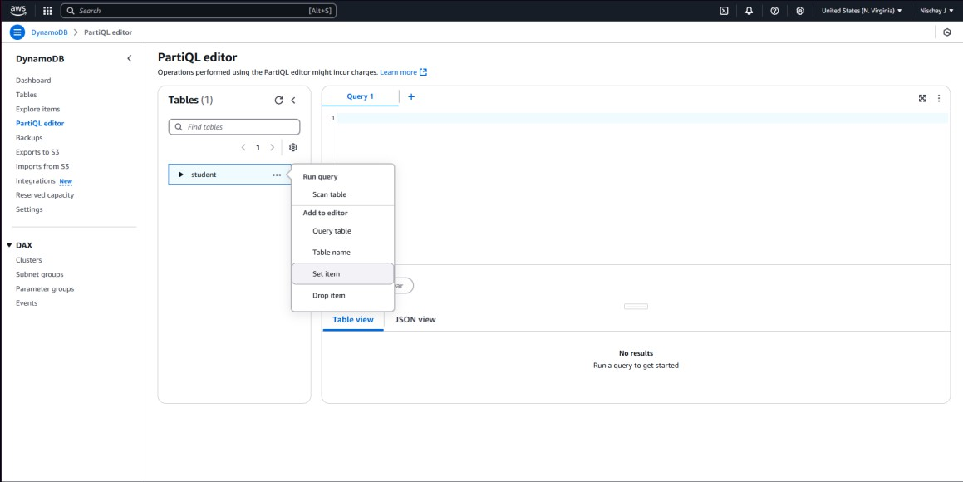**Step 15:** Now Click on “Set item”, once it is executed, select “scan table” for the updated table

**Step 16:** Click on “Drop item”, and once again select the “scan table” for the updated table

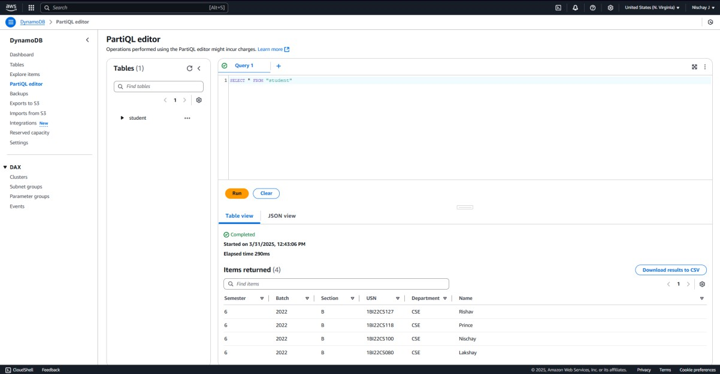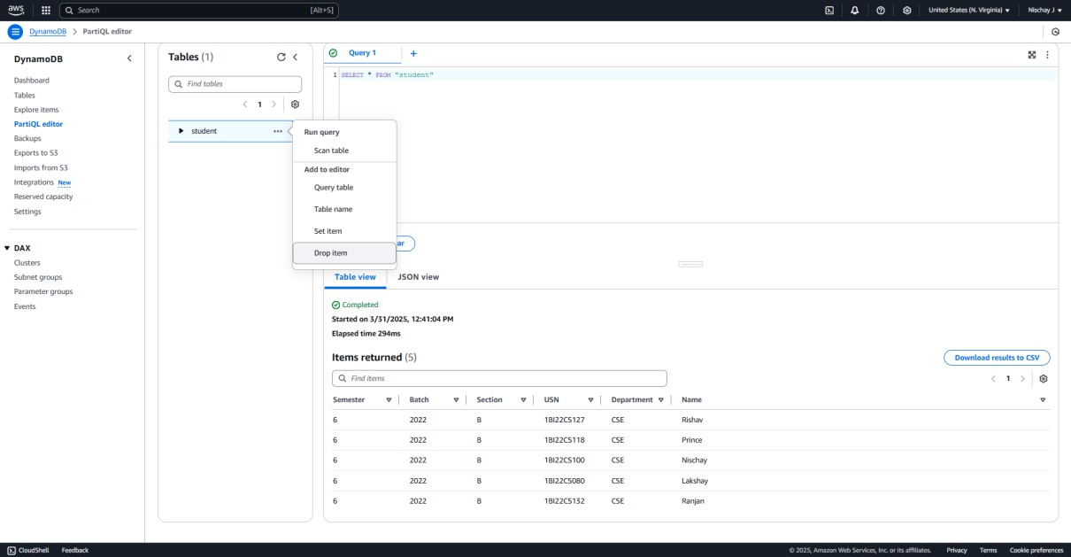

**Step 17:** Delete the table “student”, by clicking on “Delete” under “Actions”

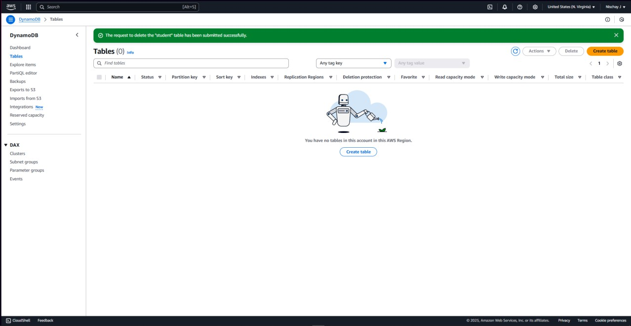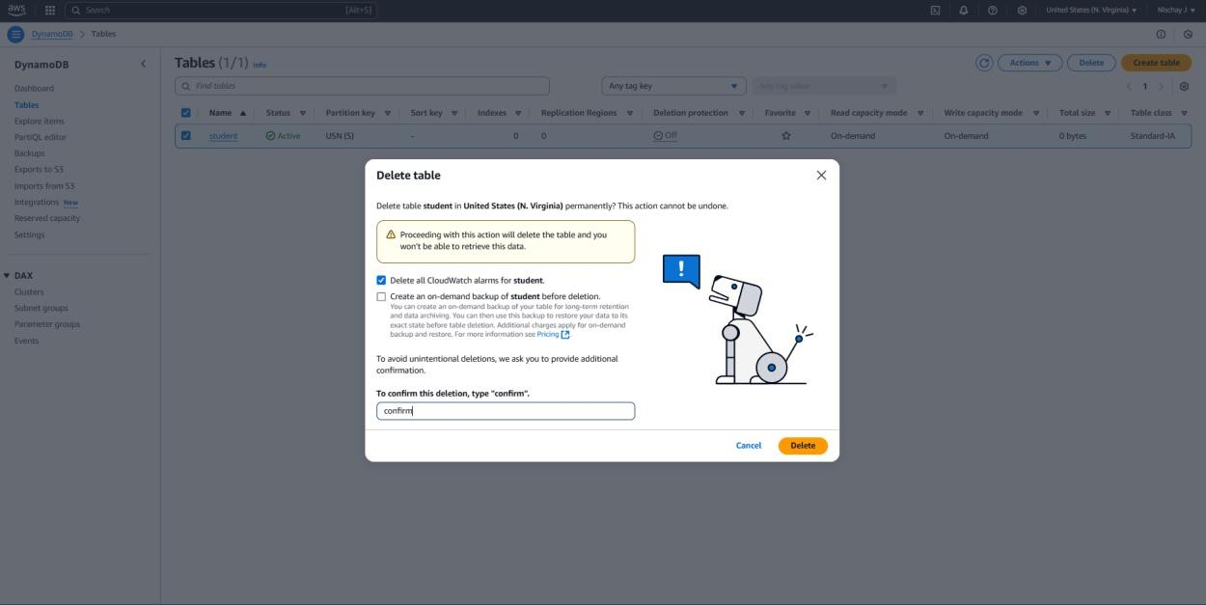

**PROGRAM 3 : Developing REST APIs with Amazon API Gateway**

Steps for creating a REST API:

Step 1: Open AWS and Sign In to the Console.

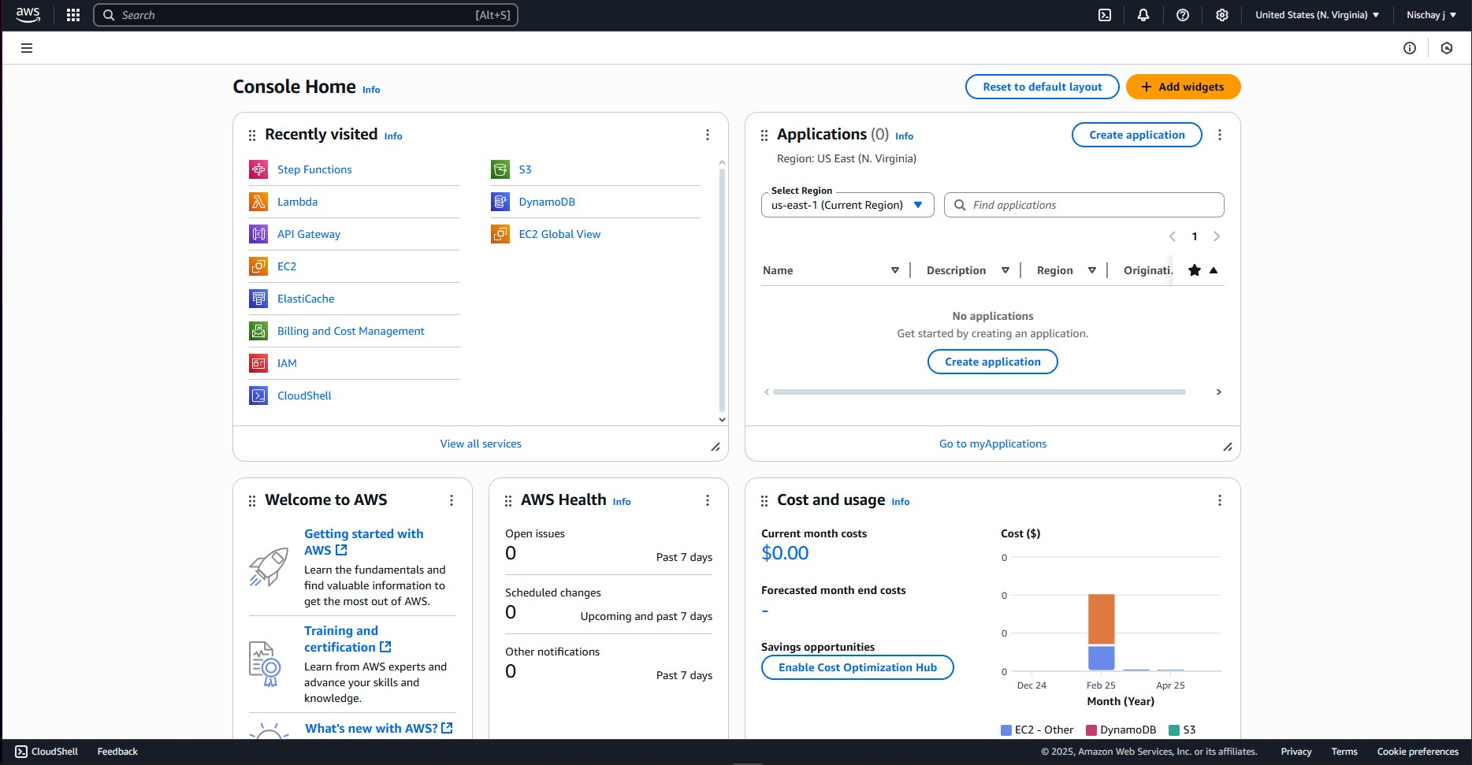

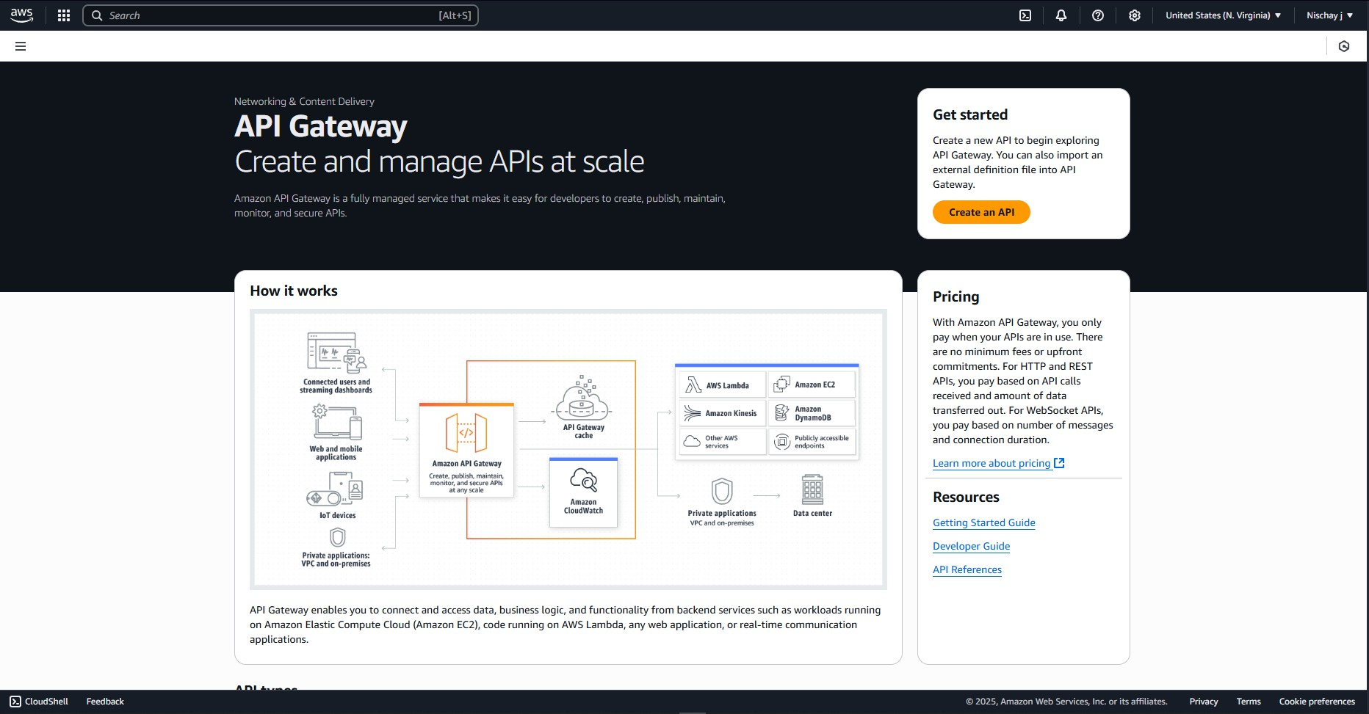**Step 2:** Open Amazon API Gateway dashboard.

**Step 3:** Choose an API type window appears scroll down to find REST API and click Build.

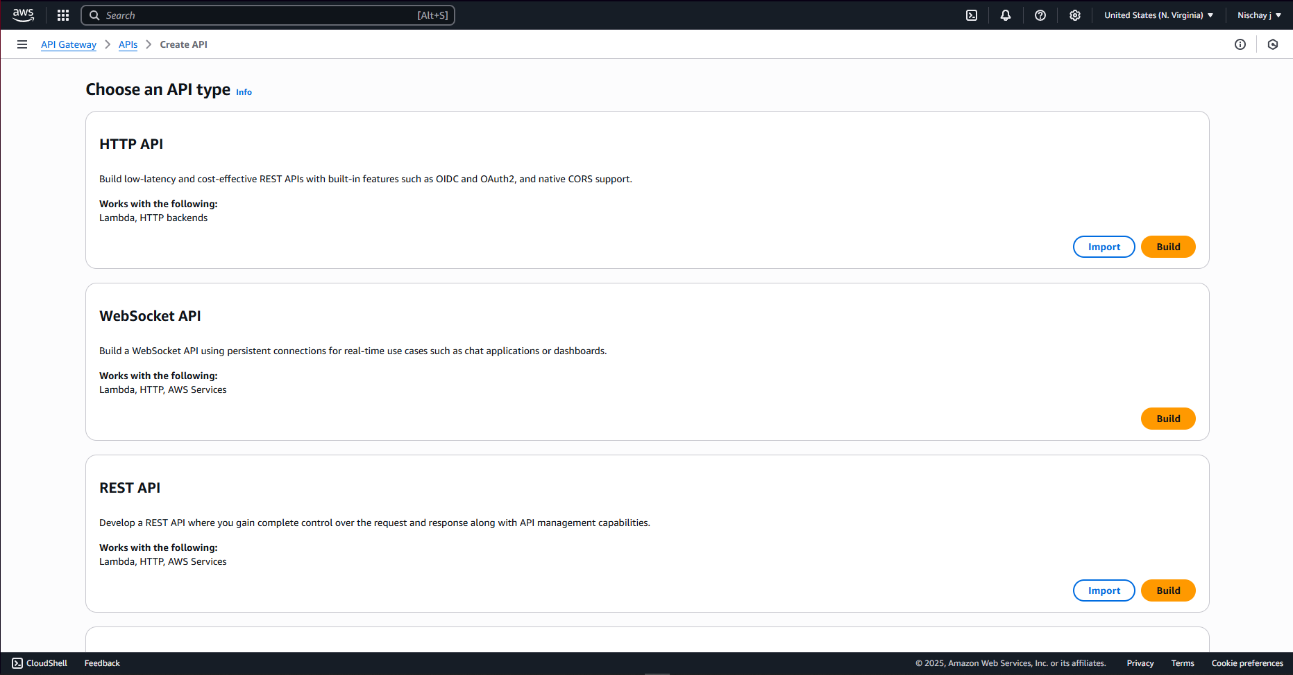

**Step 4:** Select New API, give a name and scroll down, click on Create API.

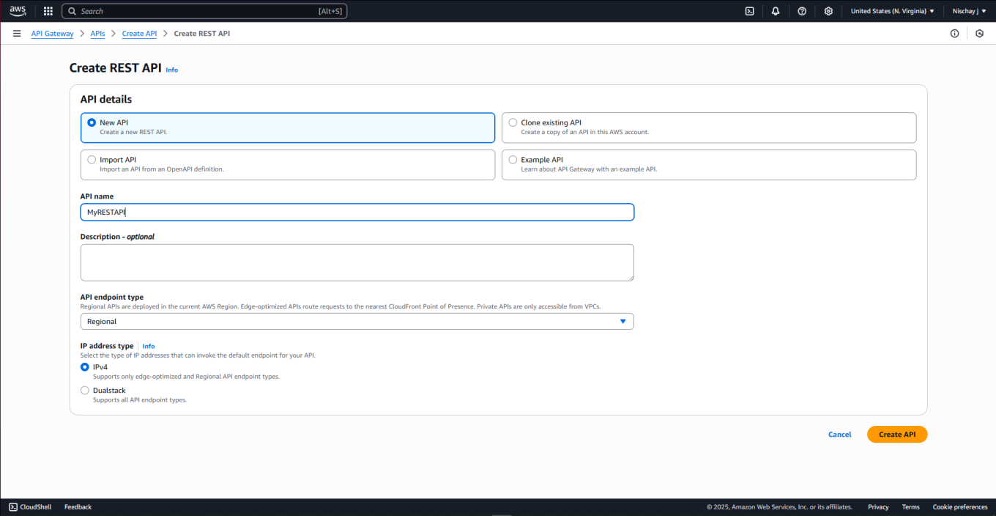

**Step 5:** Successful creation notification is displayed, click on Create method.

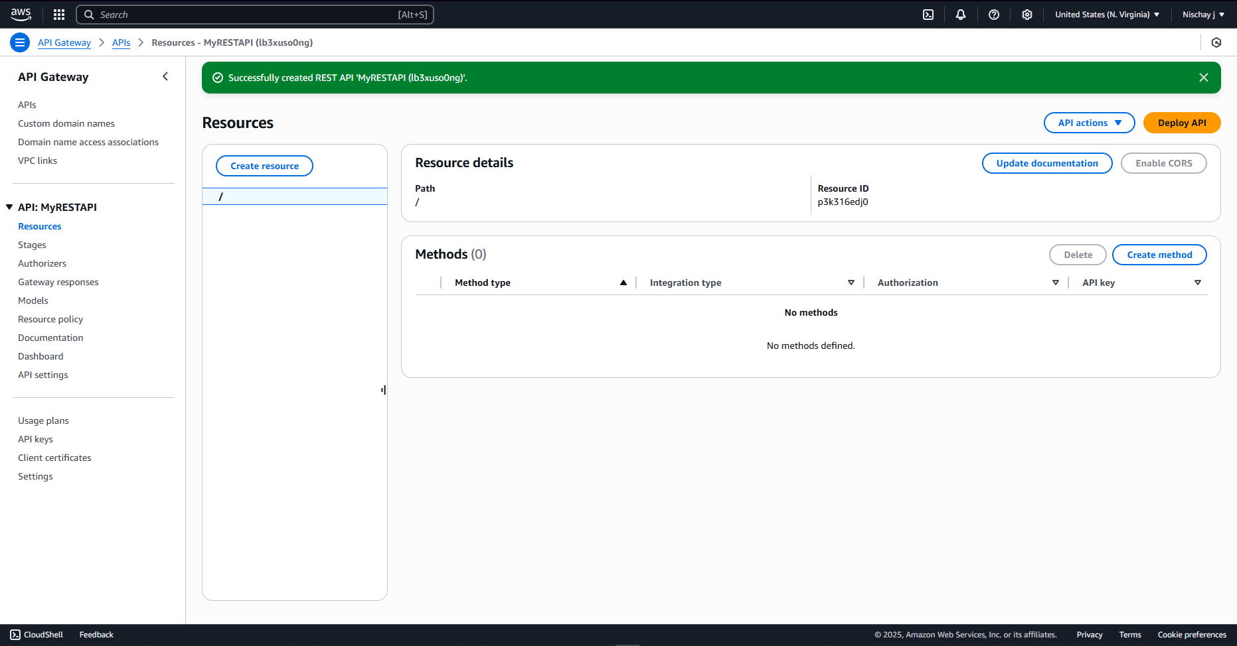

**Step 6:** Open link in new tab and create Lambda Function.

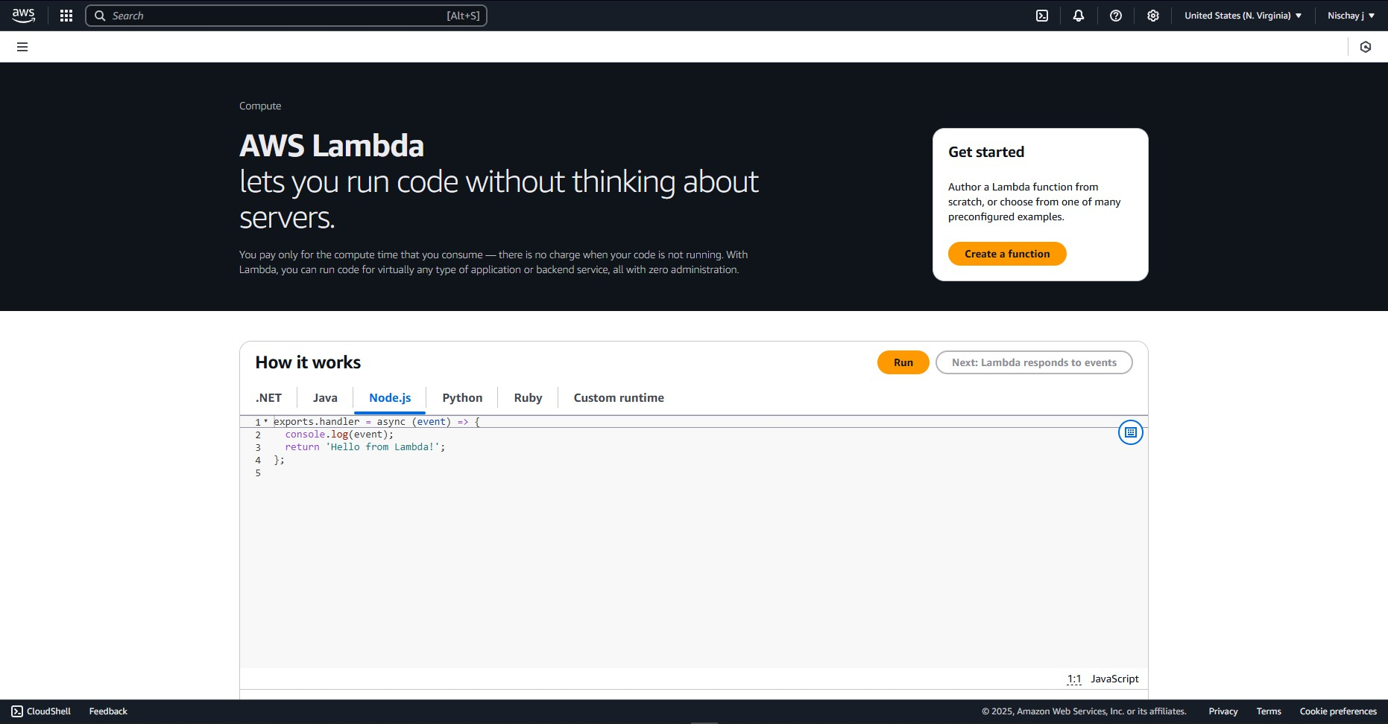

**Step 7:** Enter the function name and ‘Python 3.13’ as runtime.

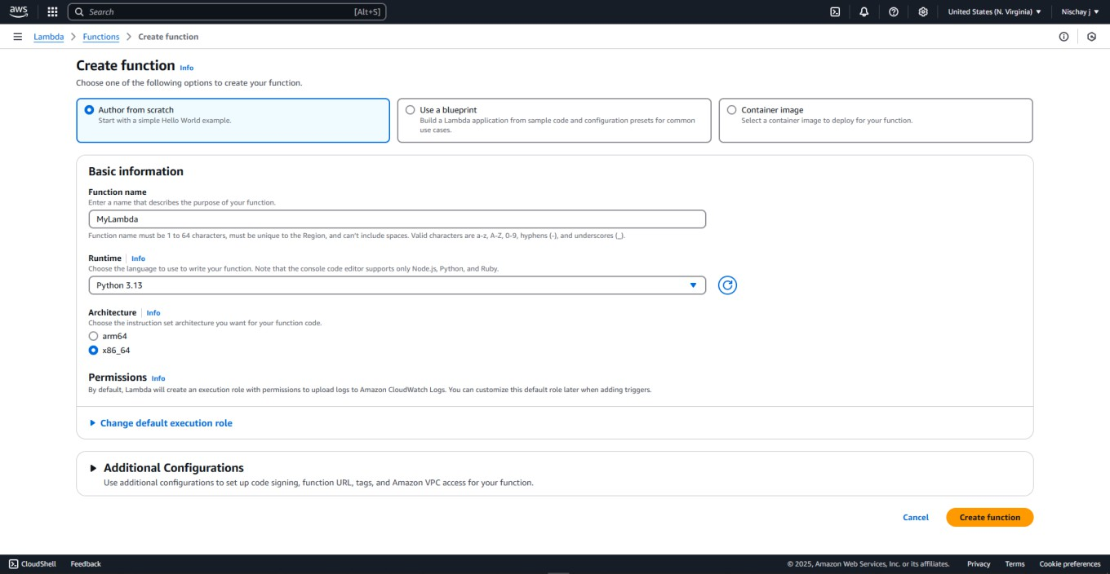

**Step 8:** Enable function URL and keep Auth type as NONE.

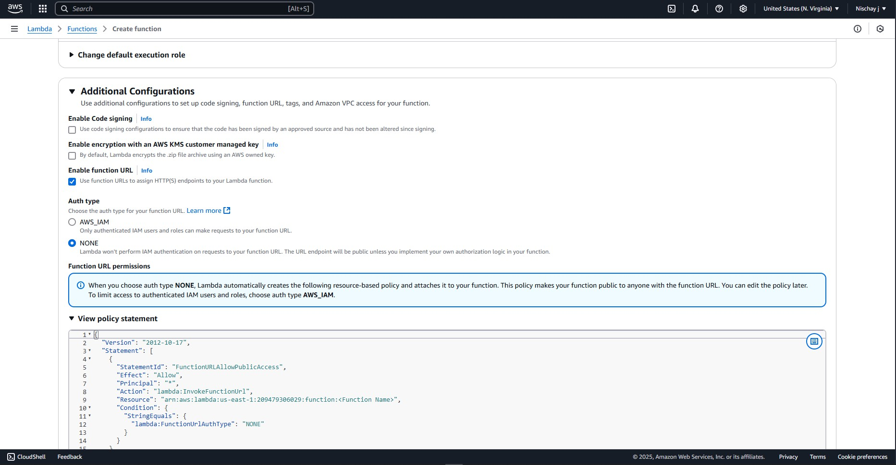

**Step 9:** Now, go to REST API, choose create method, choose HTTP and HTTP method, and choose lambda function, paste function ARN and create method.

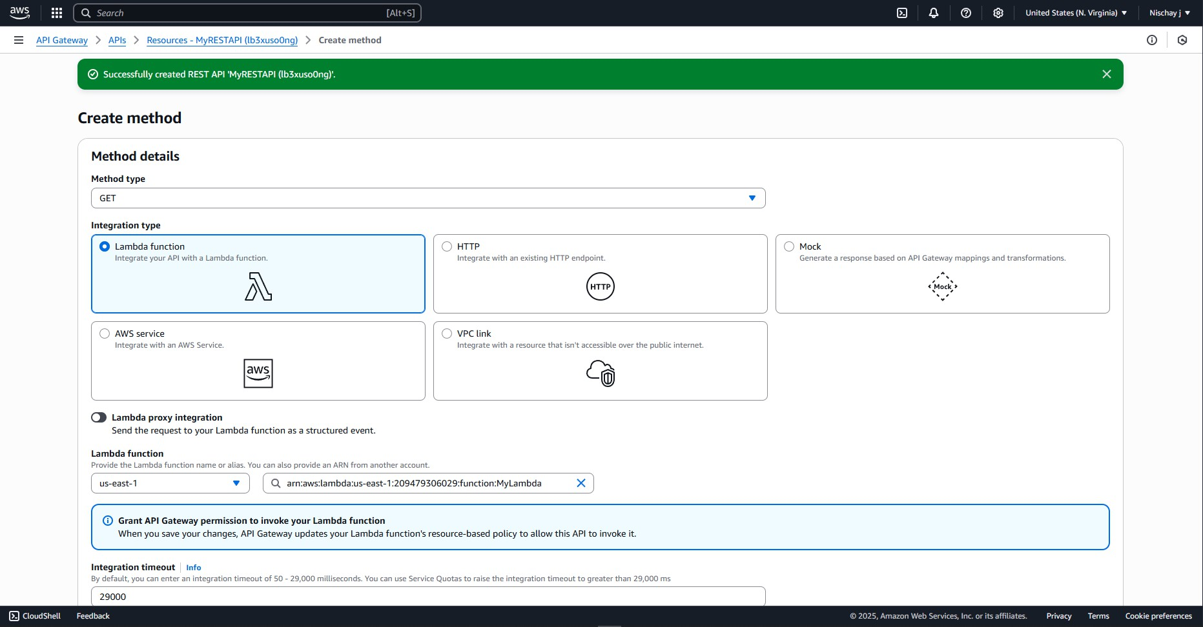

**Step 10:** Successfully created ‘GET’ method.

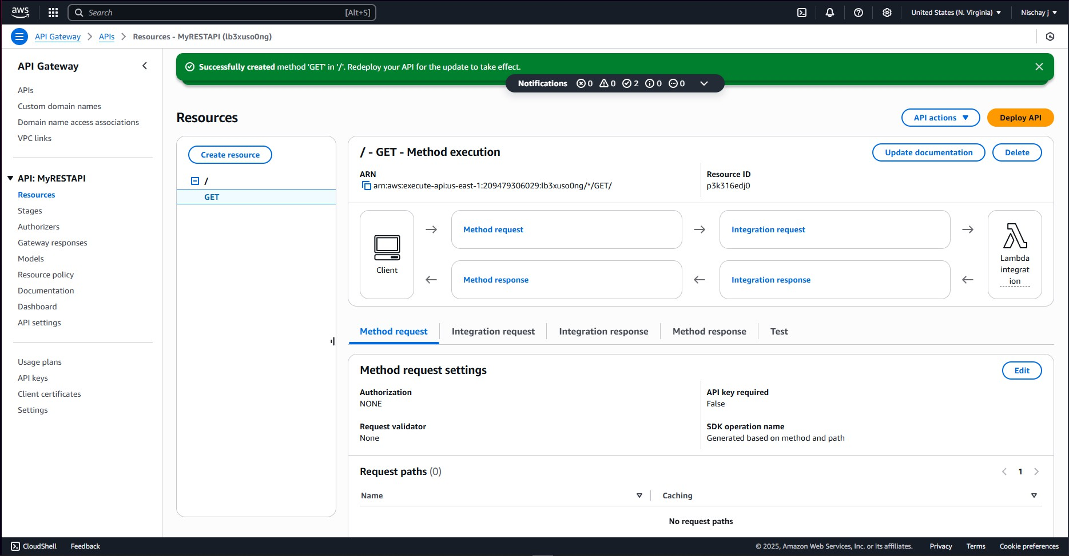

**Step 11:** In Deploy API dialog box give Stage as ‘New Stage’ and give it name then click on Deploy

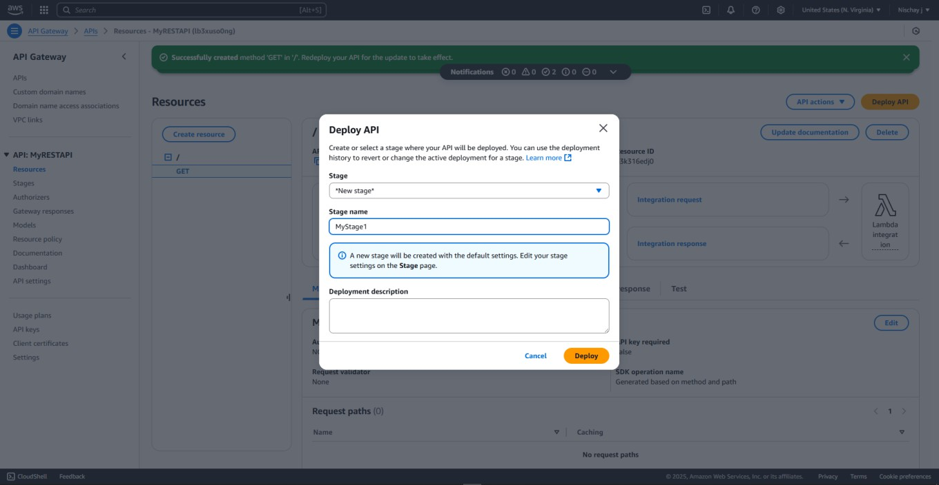

**Step 12:** Successfully created deployment for MyRESTAPI.

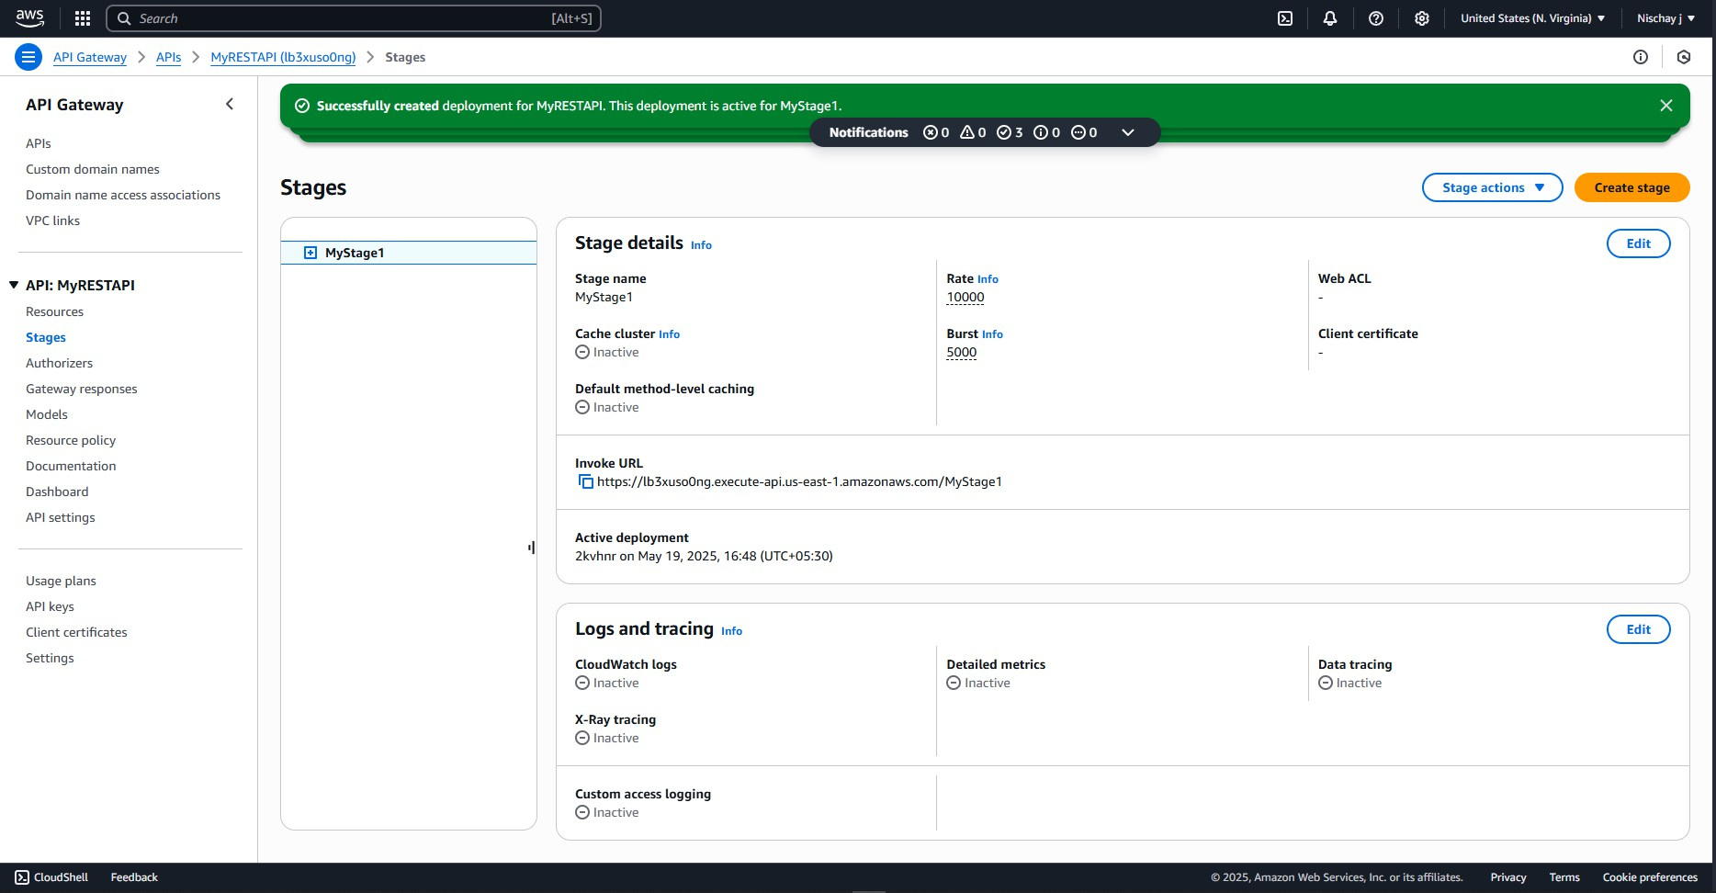

**Step 13:** copy the Invoke URL to new Tab and view Output.

# Steps for Deletion of REST API:

**Step 1:** Select the API been created and click on ‘Delete’.

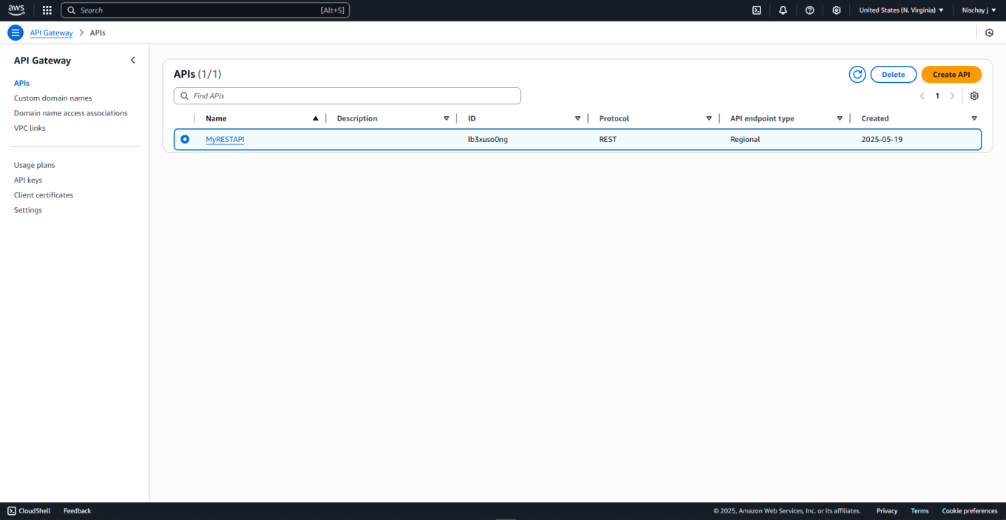

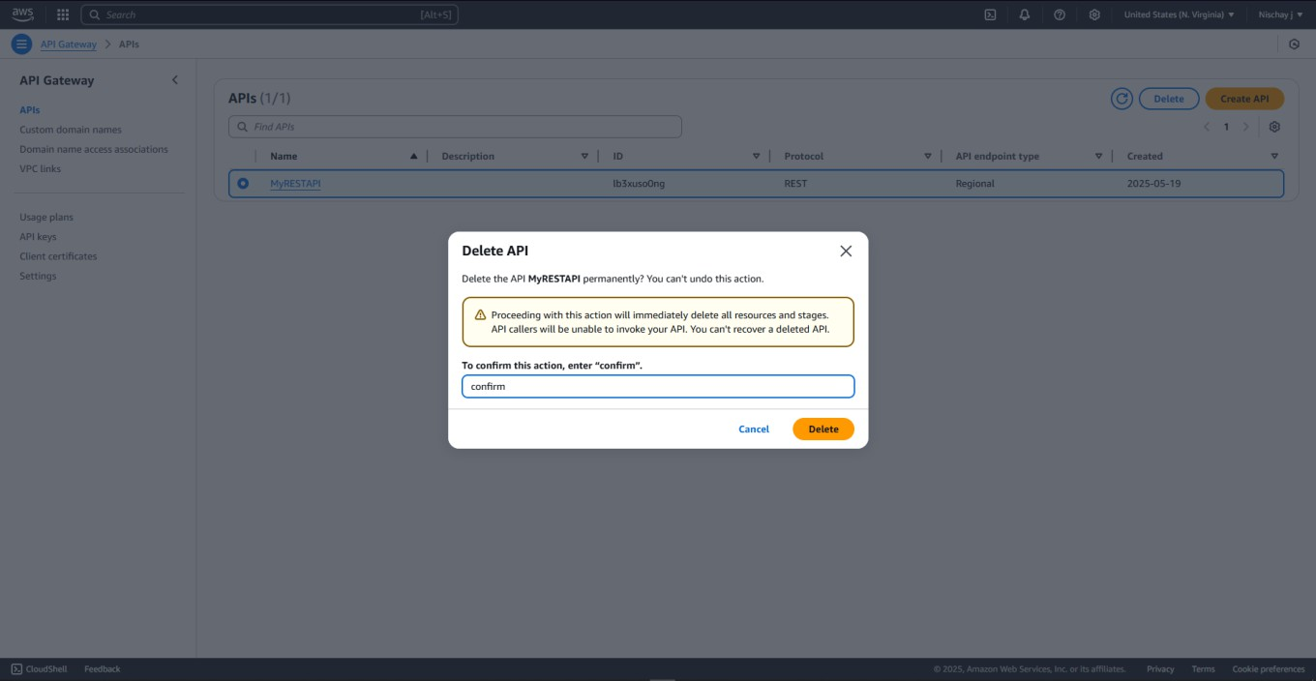**Step 2:** To confirm the action, enter ‘confirm’ and click on delete.

**Step 3:** Select the lambda function been created and click on ‘Actions’ then click on delete.

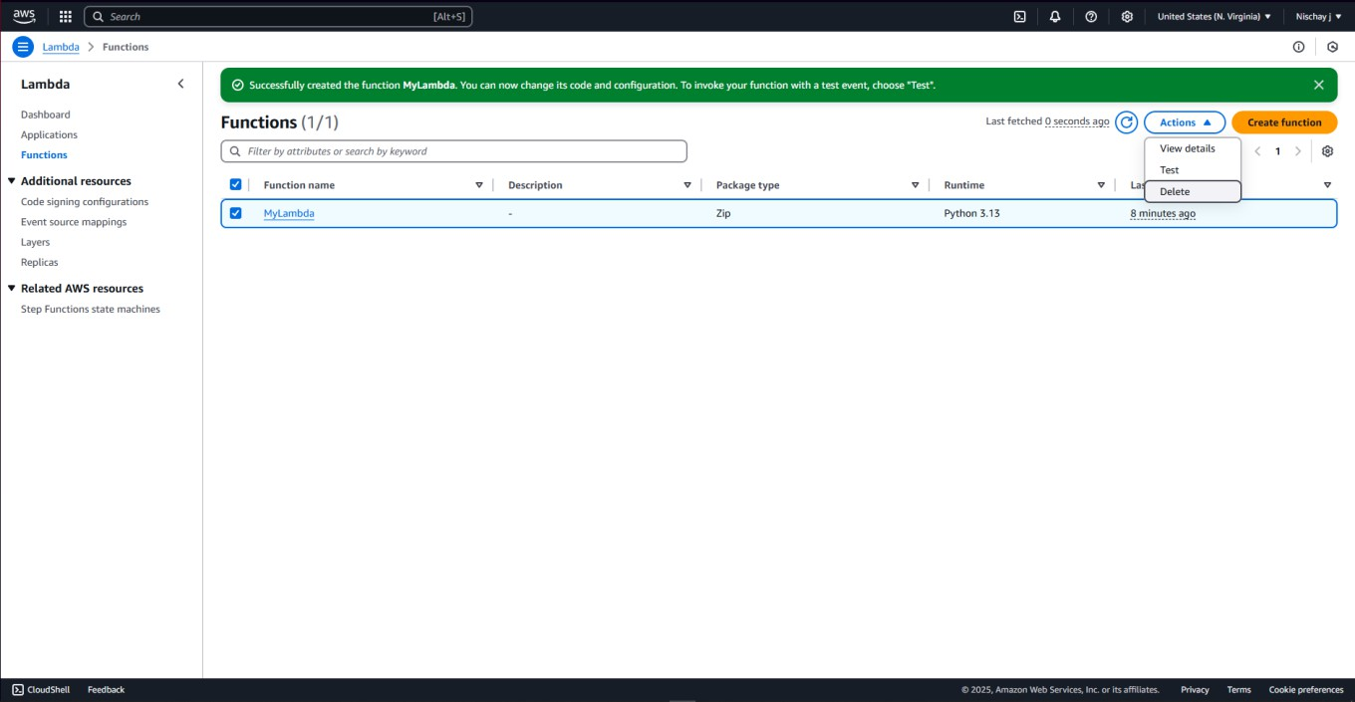

#### Step 4: To confirm the action, enter ‘confirm’ and click on delete Step 5: Lambda function is deleted successfully

# PROGRAM 4: Migrating a Web Application to Docker Steps for creating an EC2 Instance

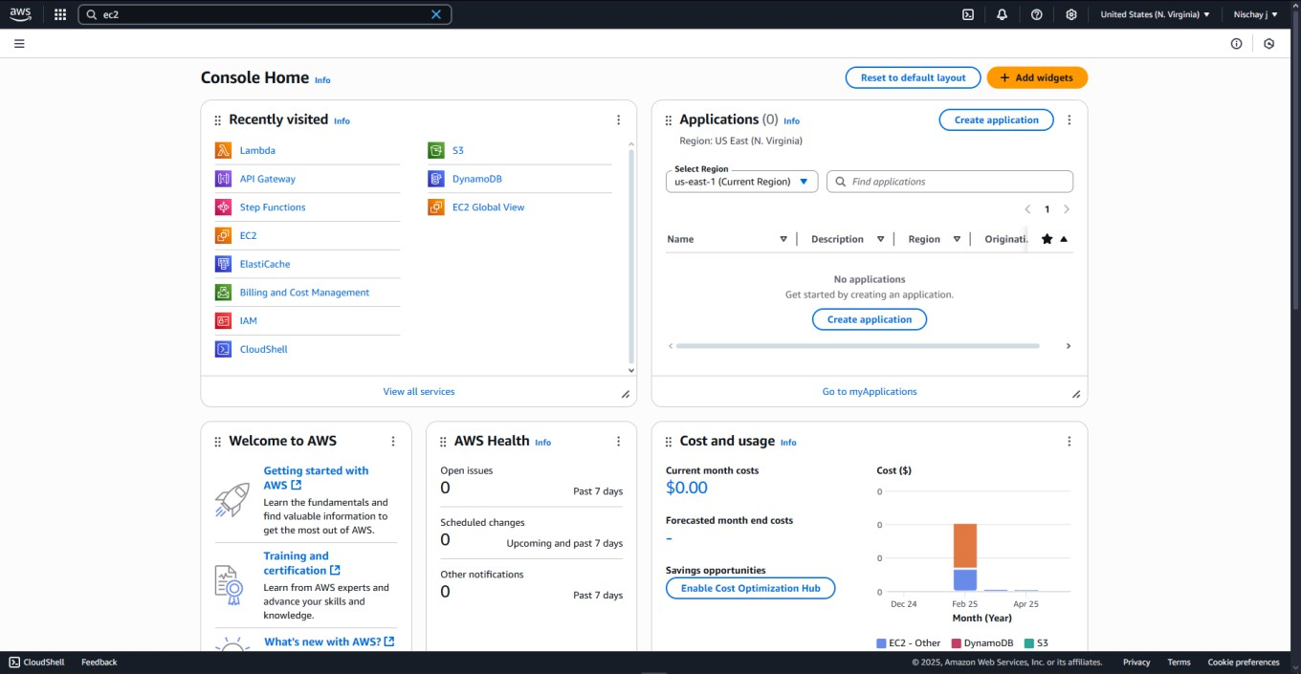**Step 1:** Open AWS and Sign In to the Console.

**Step 2:** Open Amazon EC2 dashboard.

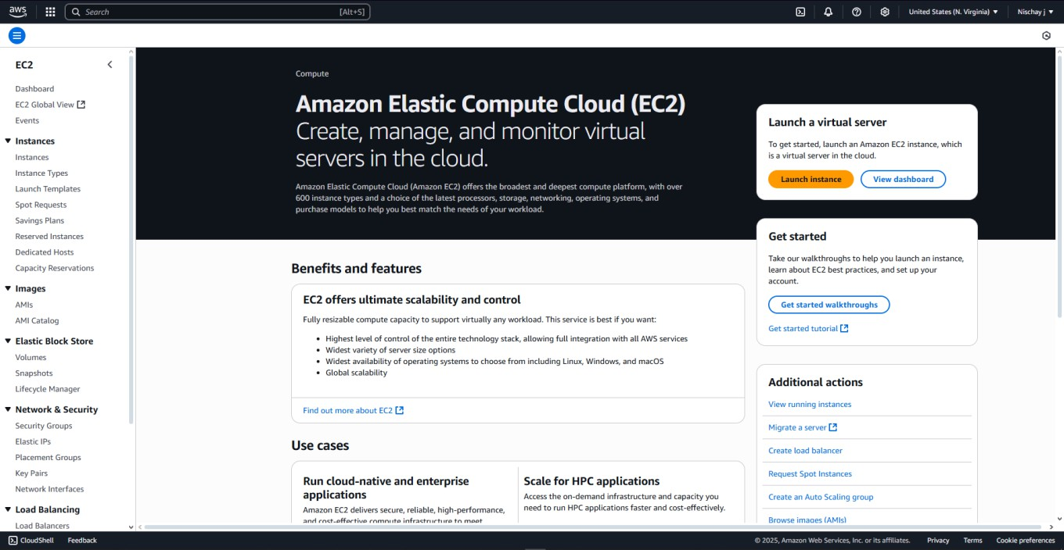

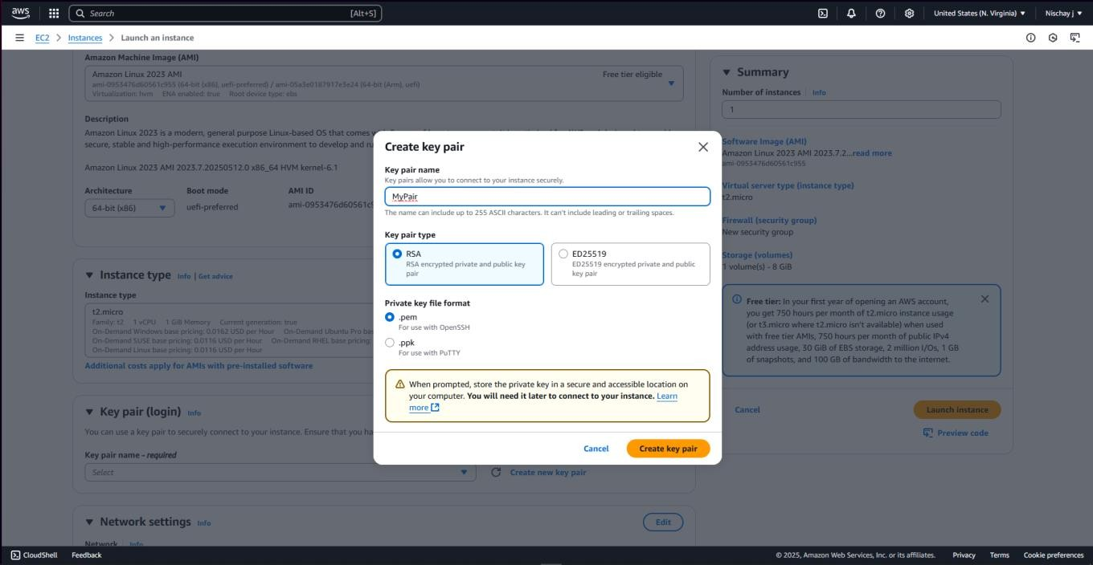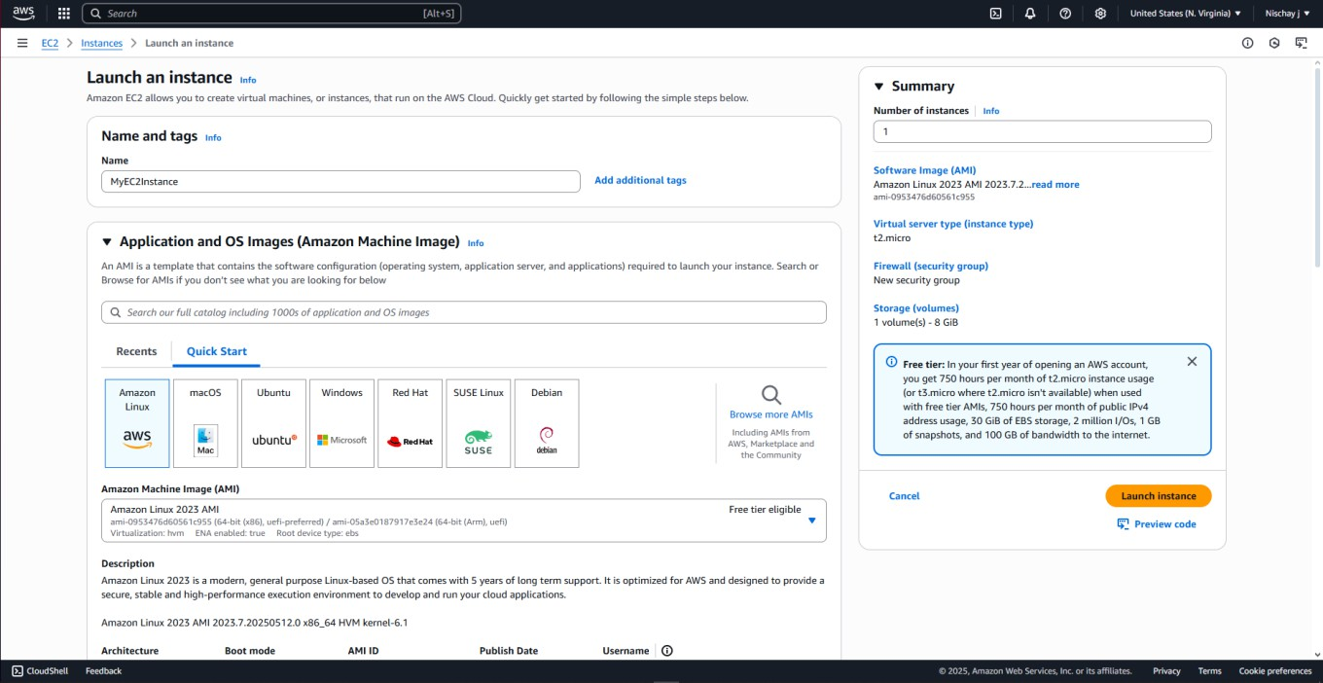Step 3: **Fill the Name and select ‘Amazon Linux’ Step 4:** Click on create key pair and generate new pair.

**Step 5:** Enable HTTPS and HTTP traffic.

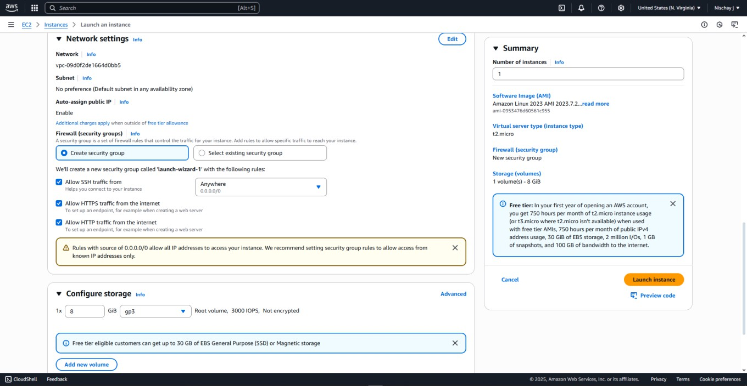

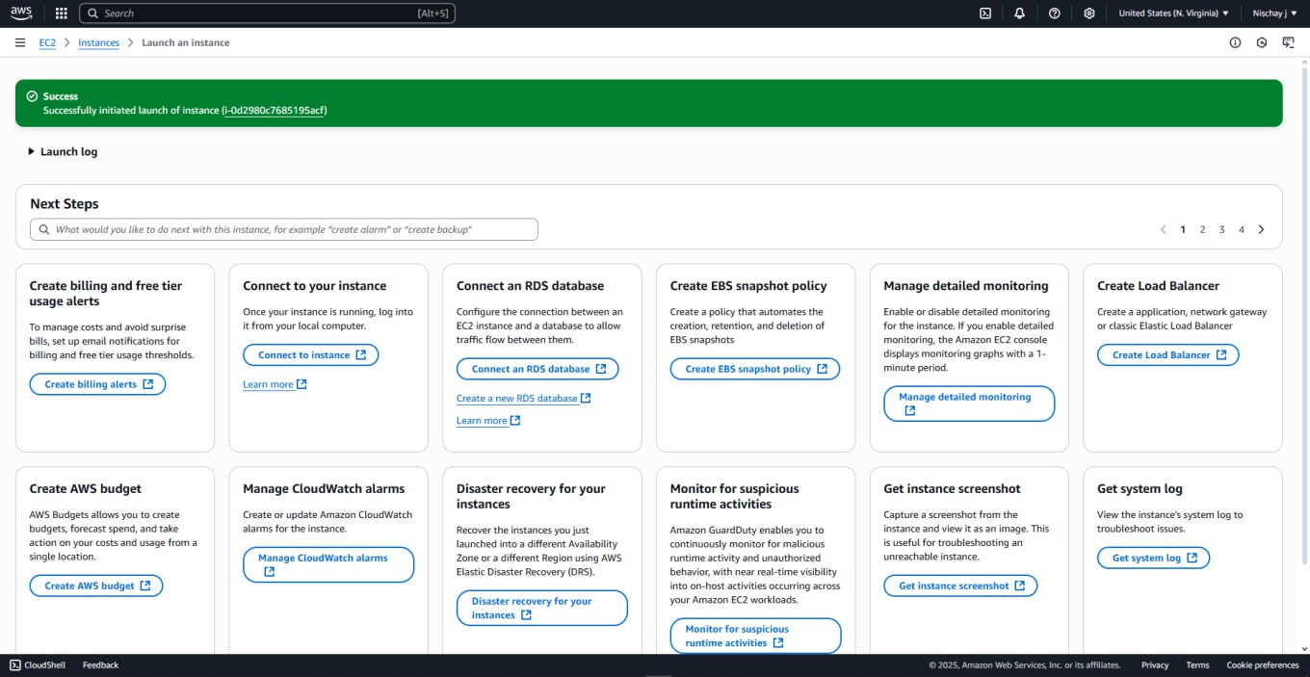**Step 6:** Instance has been successfully launched

**Step 7:** Click on instance and select ‘connect’.

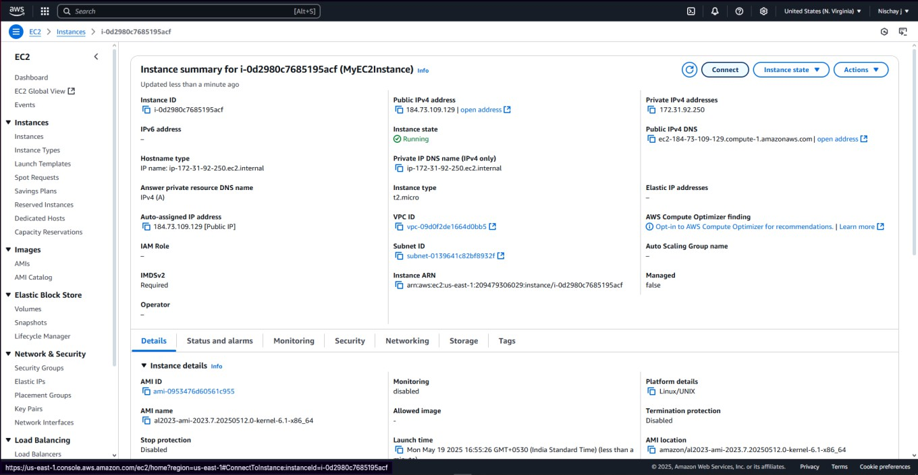

**Step 8:** Then again click on ‘connect’.

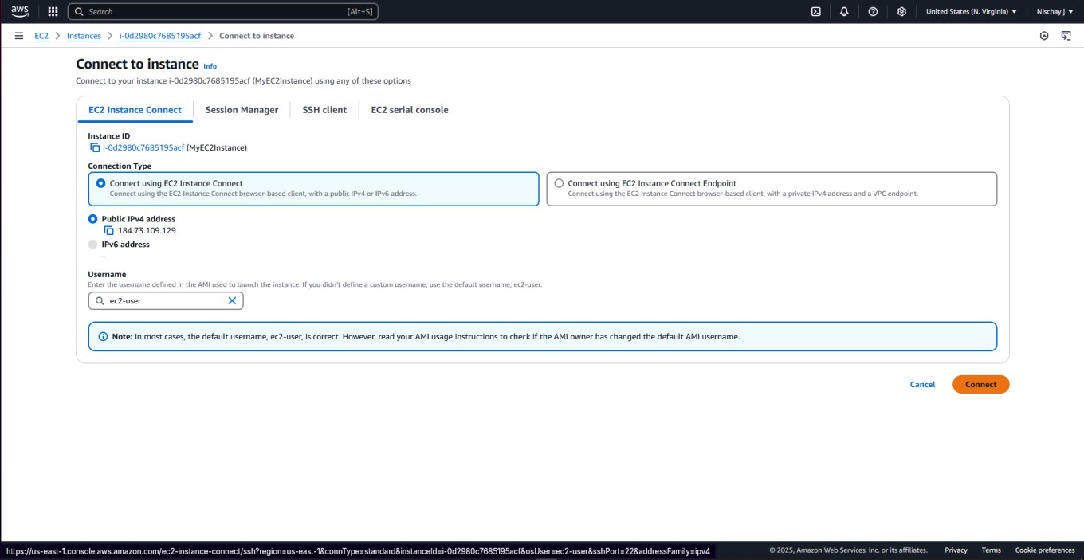

# Steps for migrating a Web Application to Dockers:

# Step 1: Amazon Linux Shell is opened

**Step 2:** Run ‘sudo yum update -y’ command to update or get newer features if available

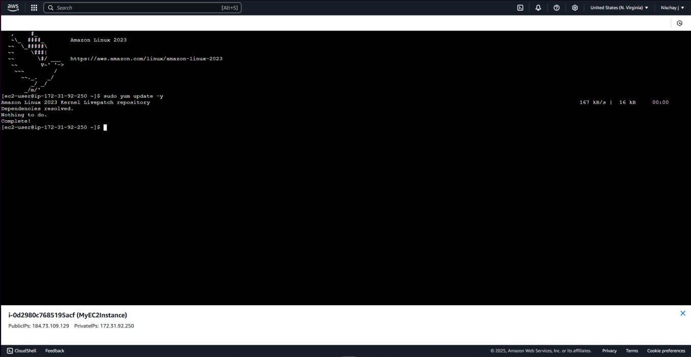

**Step 3:** Run ‘sudo yum install docker -y’ command to install Docker application on our instance.

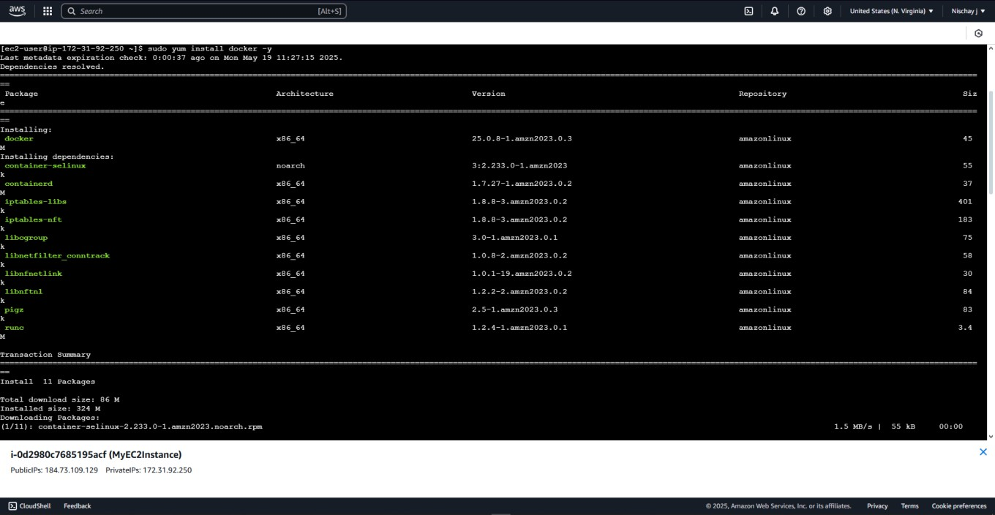

**Step 4:** Run ‘sudo service docker start’ command to start docker service on our instance.

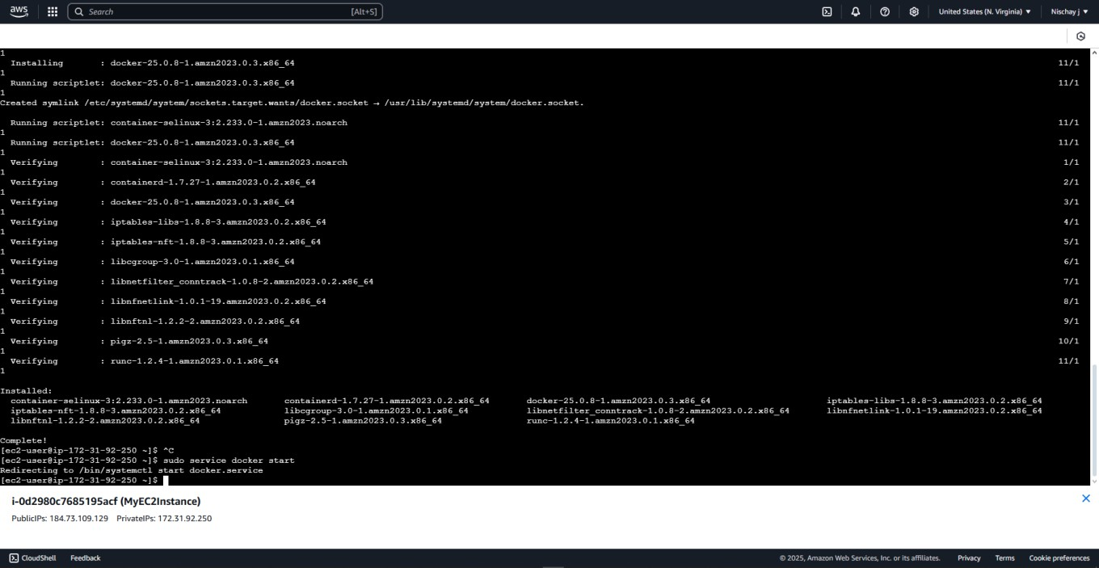

**Step 5:** Run ‘sudo service docker status’ command to check if Docker is running.

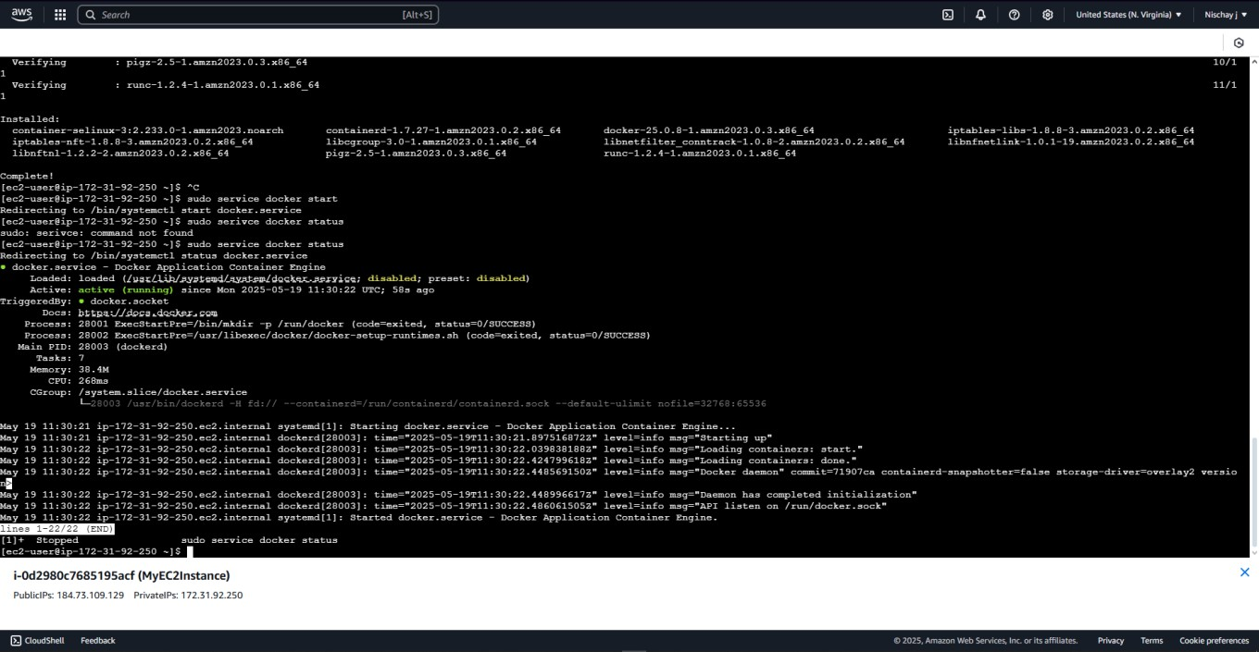

**Step 6:** Run ‘sudo su’ and ‘docker version’ command to go to root directory on our instance and to check version of Docker installed.

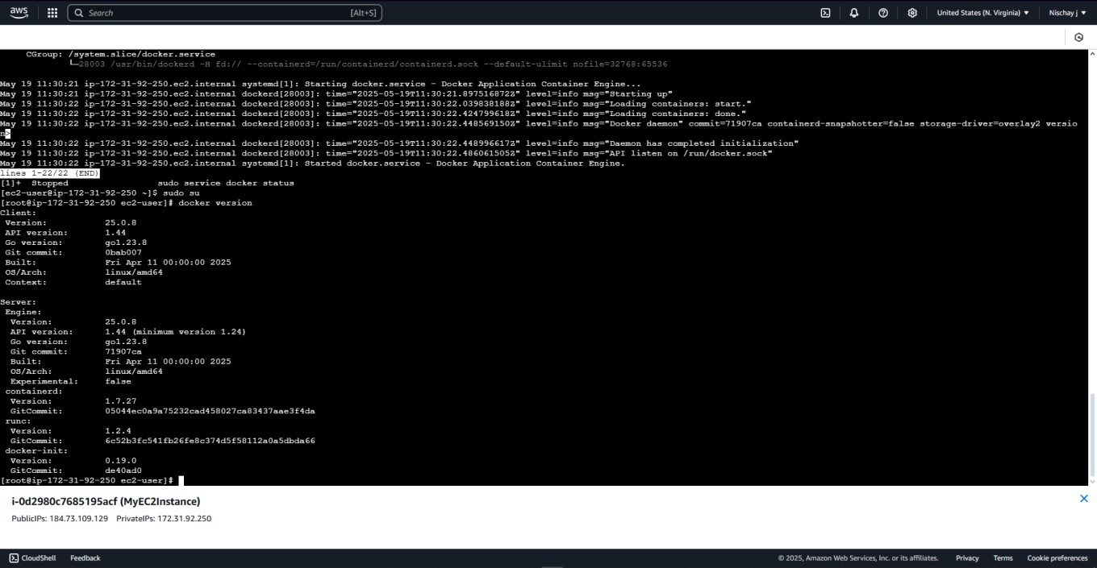

**Step 7:** Run ‘docker pull nginx’ command to download the nginx web application from Docker’s repository.

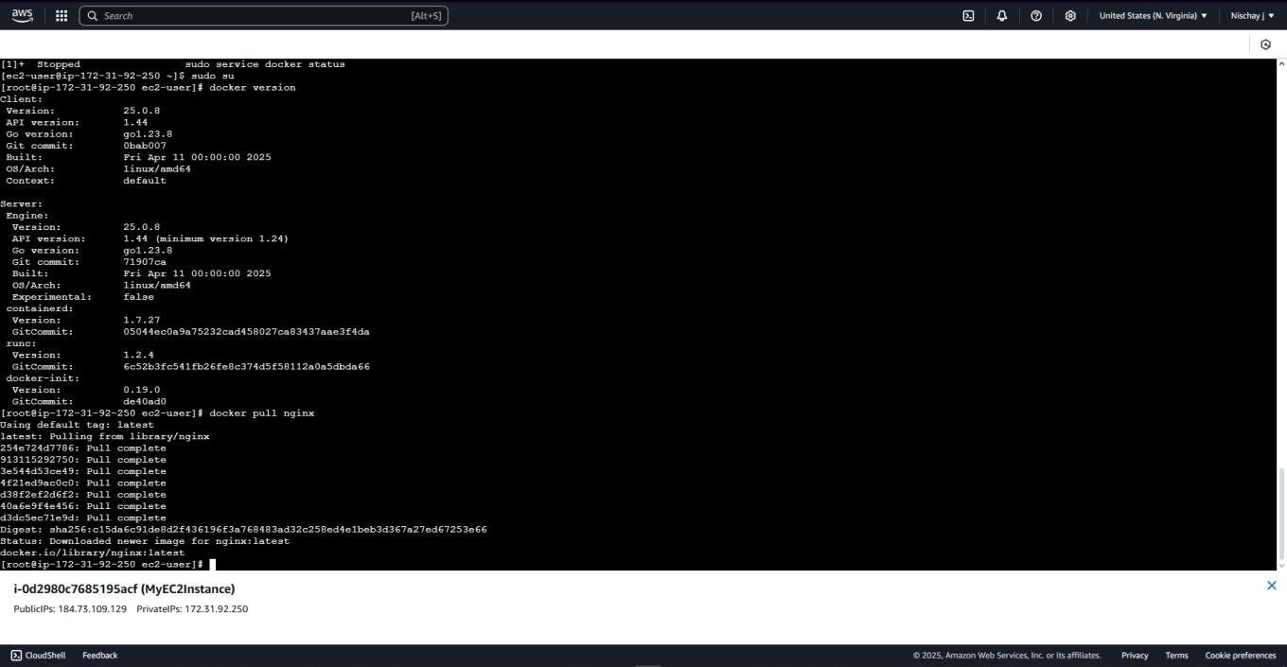

**Step 8:** Run ‘docker images’ command to see downloaded application images.

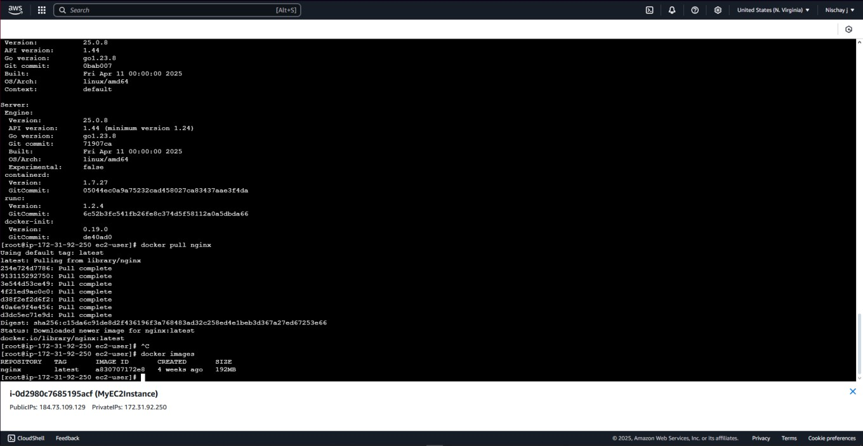

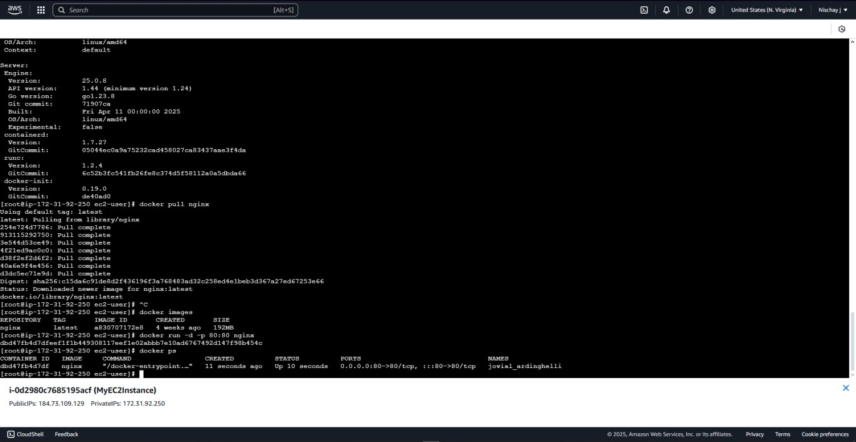**Step 9:** Run ‘docker run -d -p 80:80 nginx’ and ‘docker ps’ command to start the nginx application and to check the status of running processes under docker.

**Step 10:** Copy the public IP Address (e.g. 13.233.73.122/) to a new tab to view the running nginx application.

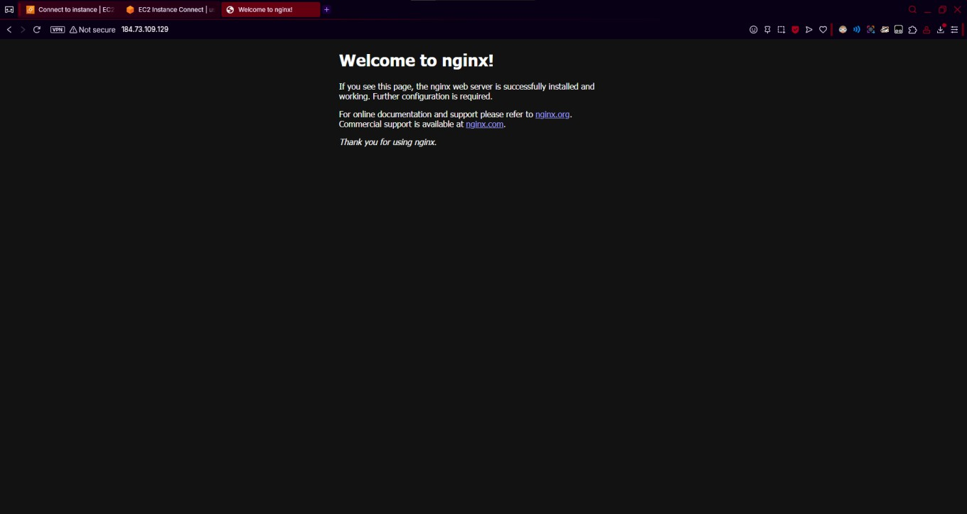

# Steps for Deletion of EC2 instance:

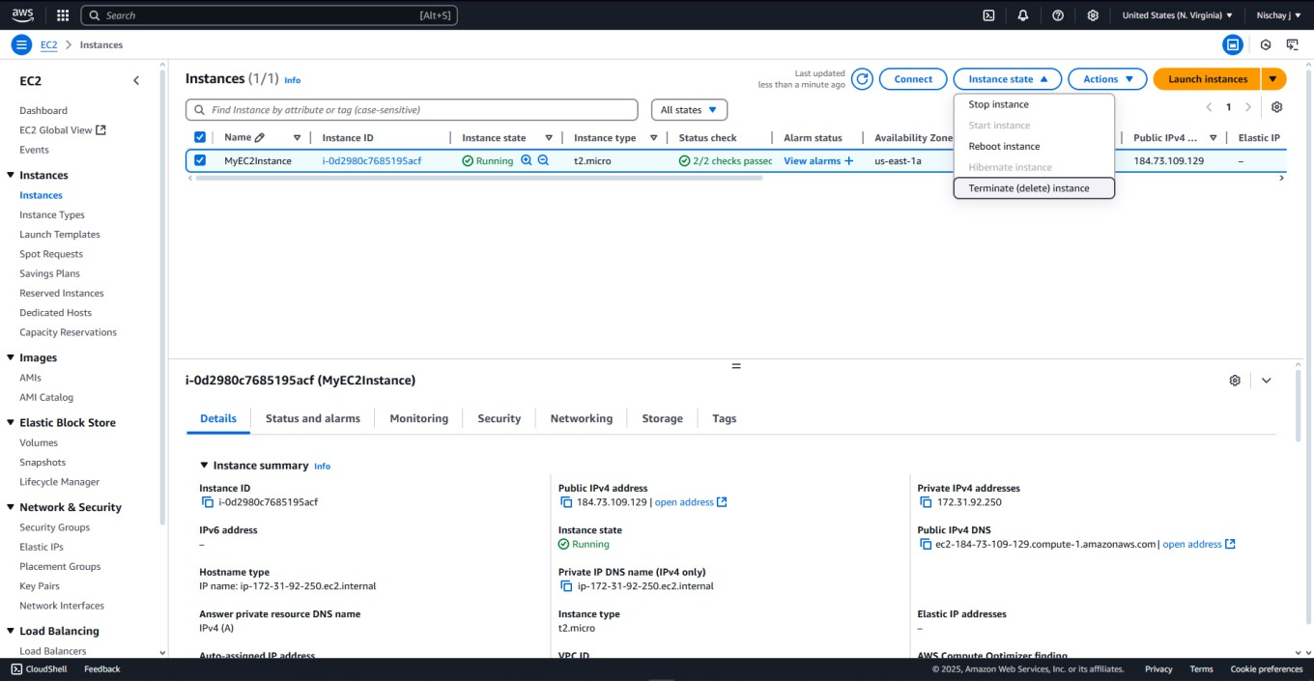**Step 1:** Select the EC2 instance been created and click on ‘Instance state’ and the click on ‘Terminate instance’.

**Step 2:** EC2 instance has been successfully terminated.

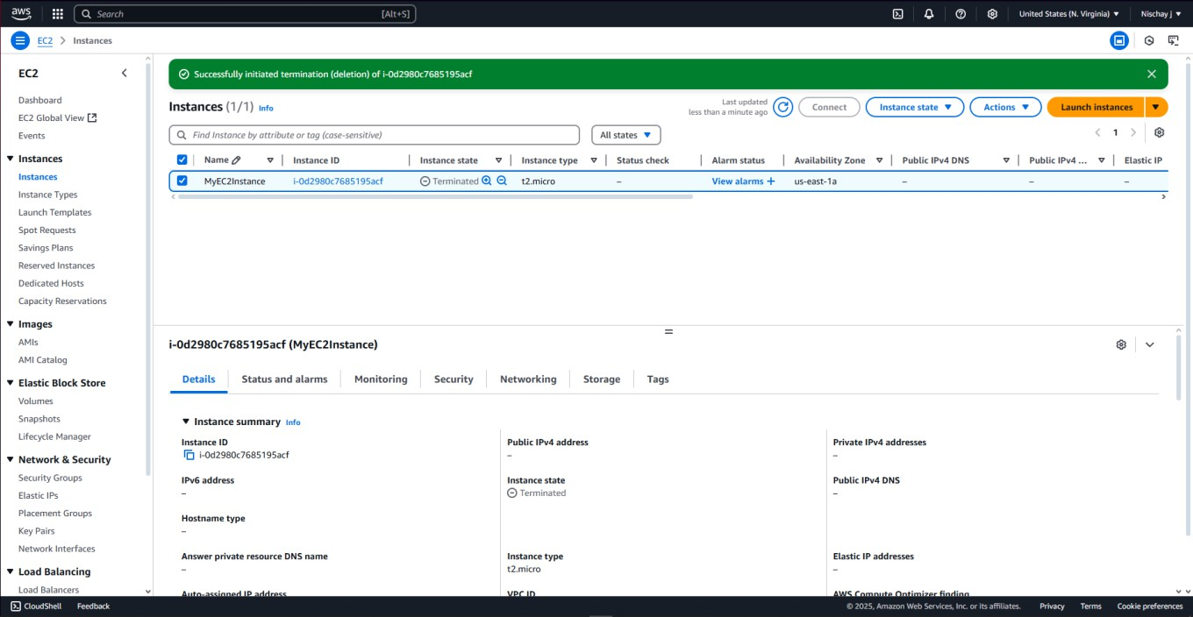

# PROGRAM 5: Caching Application Data with ElasticCache, Caching with Amazon CloudFront, Caching Strategies.

**Steps for creating an ElasticCache:**

**Step 1:** Open AWS and Sign In to the Console.

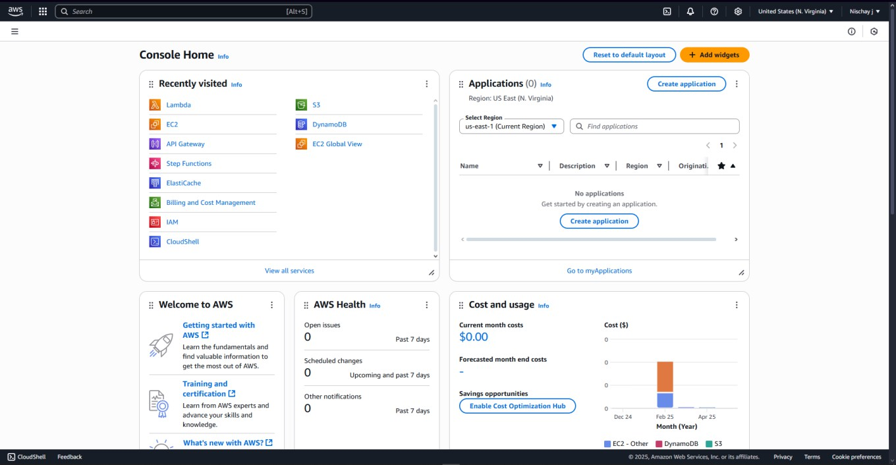

**Step 2:** Open Amazon ElasticCache

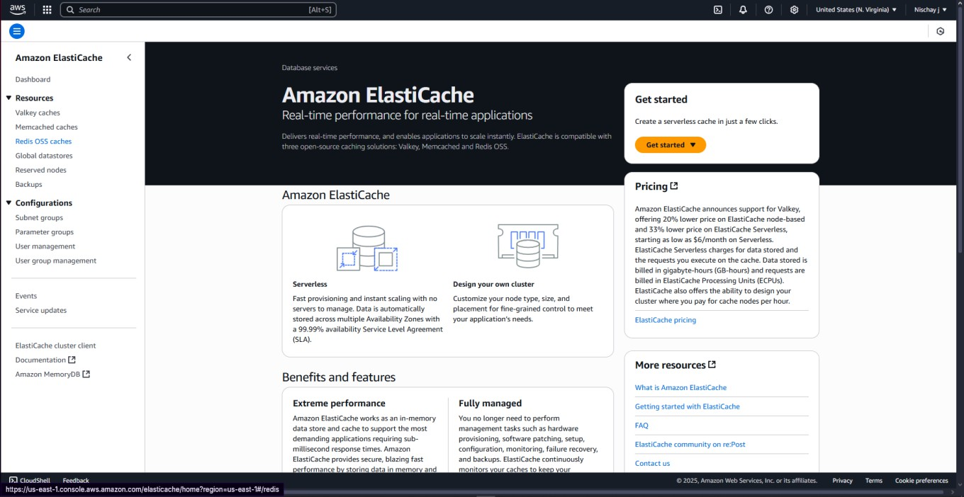

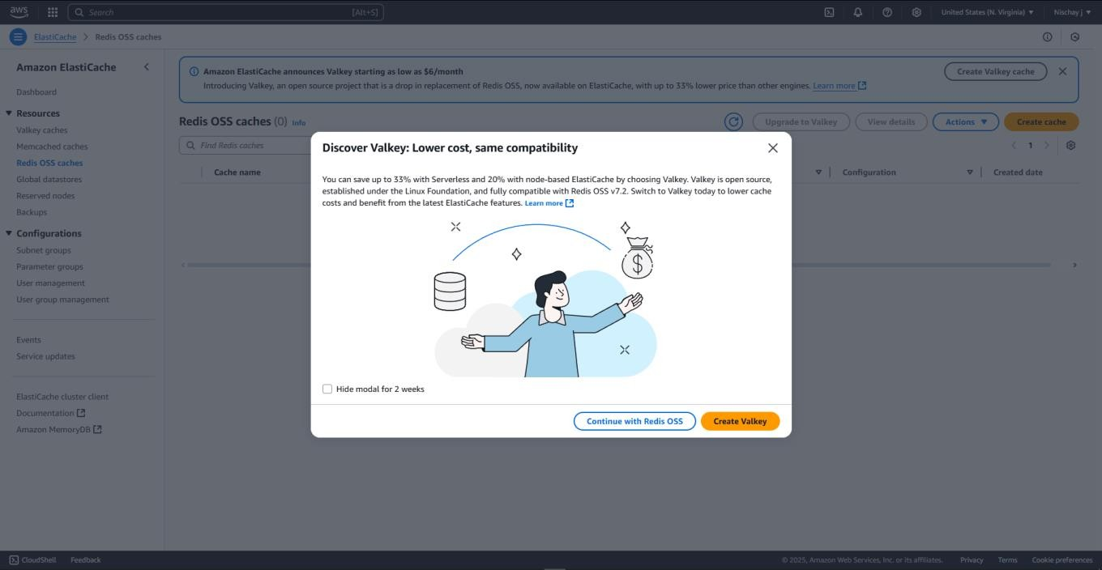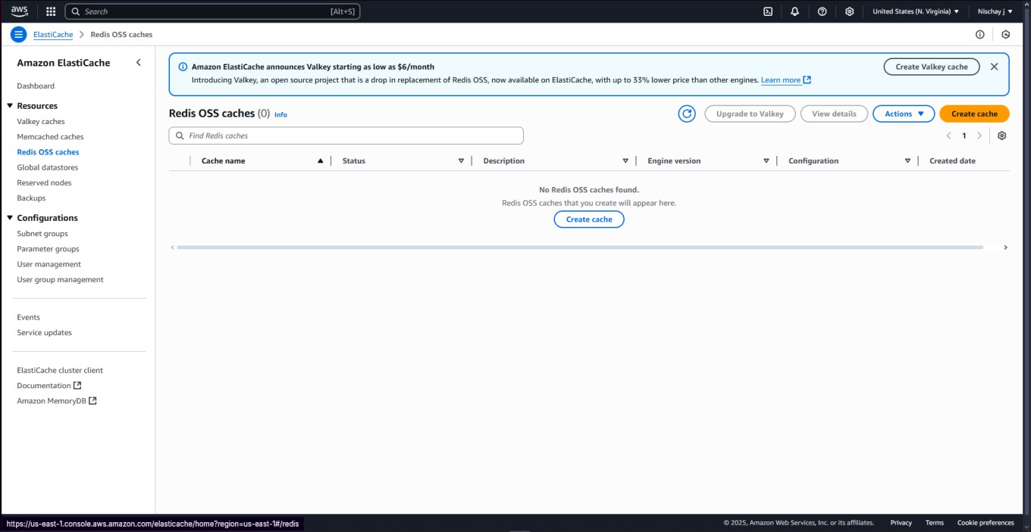**Step 3:** On the left side of the screen click on ‘Redis OSS caches’ and click on ‘create cache’. **Step 4:** Click on ‘Continue with Redis OSS’.

**Step 5:** Select ‘Redis OSS’ as an Engine, select ‘Design your own cache’ for Deployment option, select ‘Cluster cache’ for Creation method and enable the cluster mode.

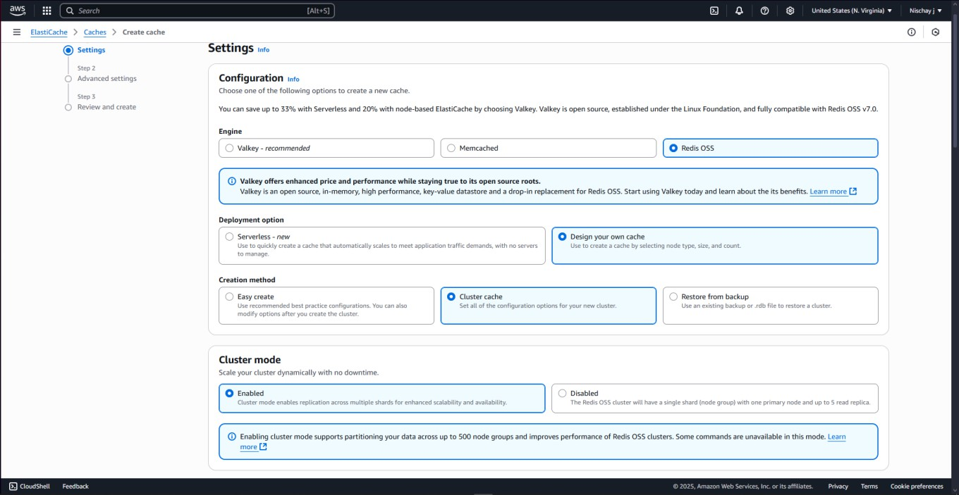

**Step 6:** Fill the Cluster name and disable ‘Multi-AZ’.

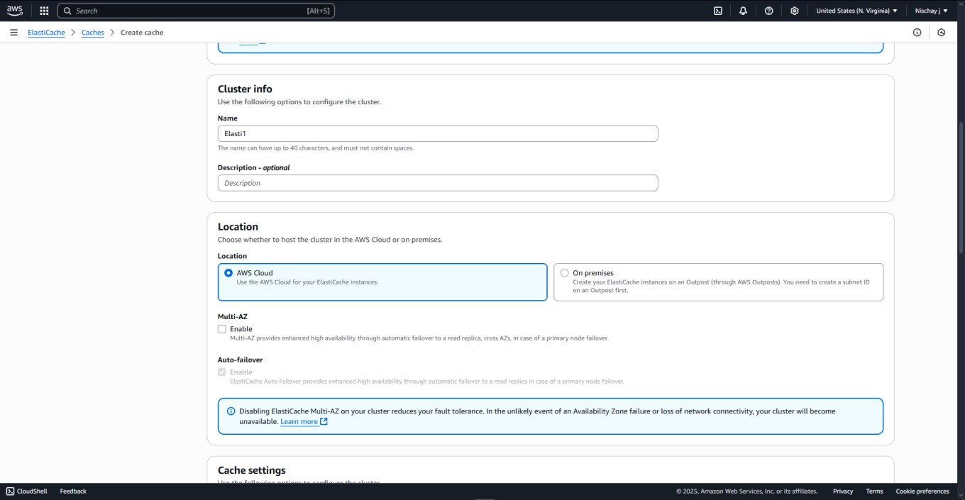

**Step 7:** Select ‘7.0’ as an Engine version, port as ‘6379’ and Node type as ‘cache.t3.micro’.

The ‘Number of shards’ should be 2 and ‘Replicas per shard’ should be 1.

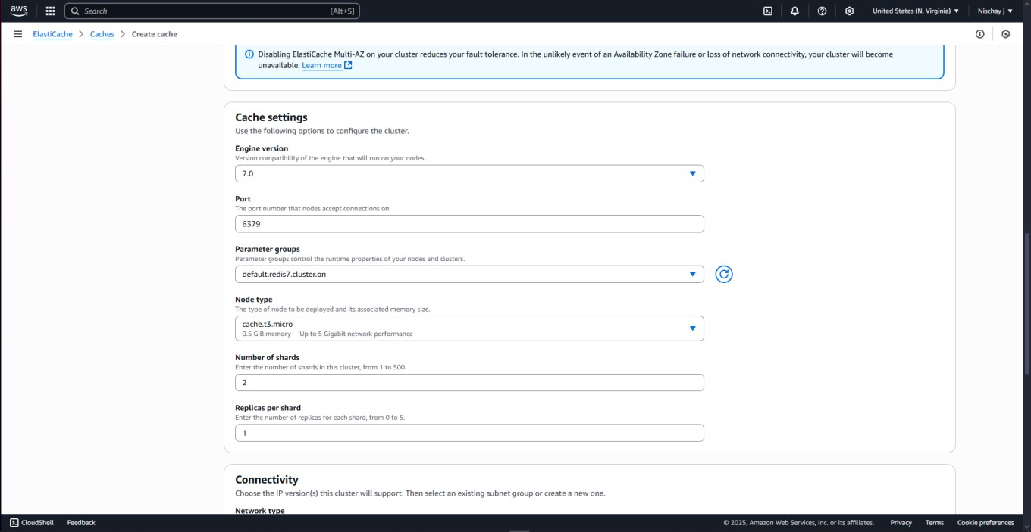

**Step 8:** Click on ‘Create a new subnet group’ and fill the name of the subnet.

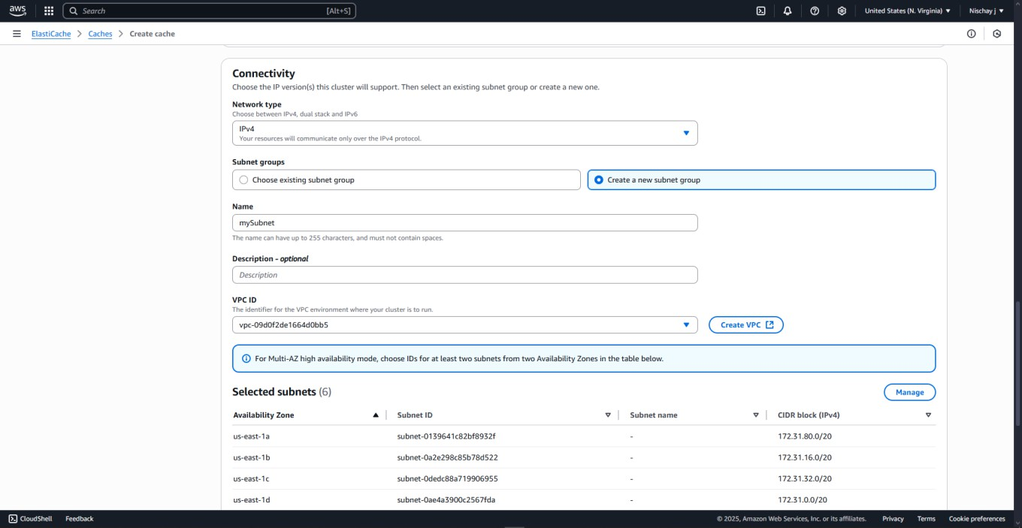

**Step 9:** Click on Manage and select ‘us-east-1a and us-east-1b’.

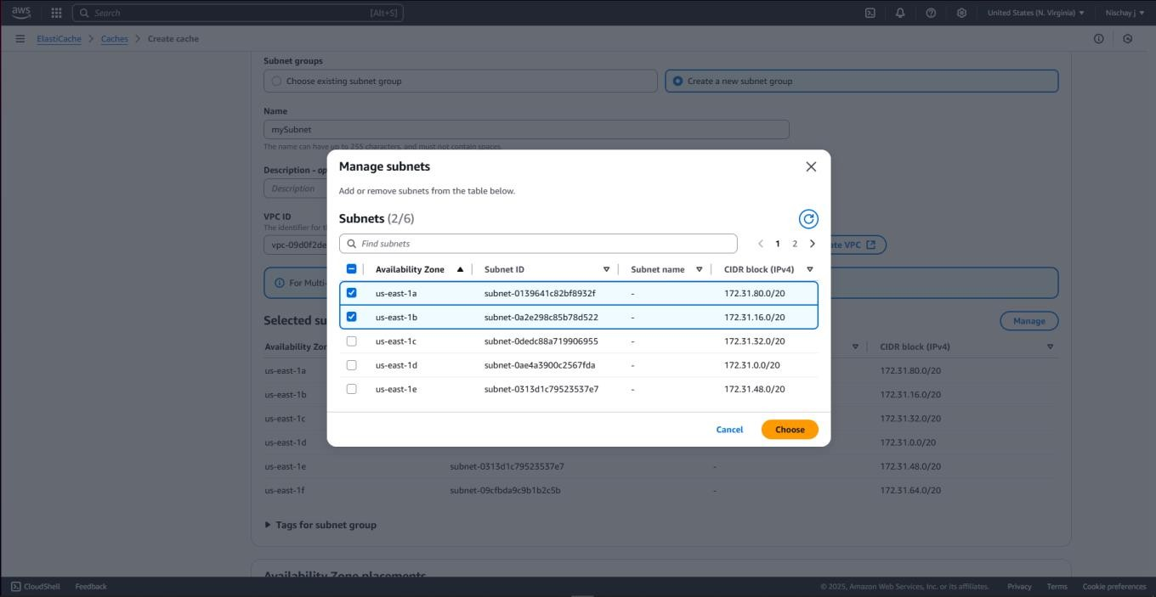

**Step 10:** Select ‘Specify Availability Zones’ option under Availability Zone placements.

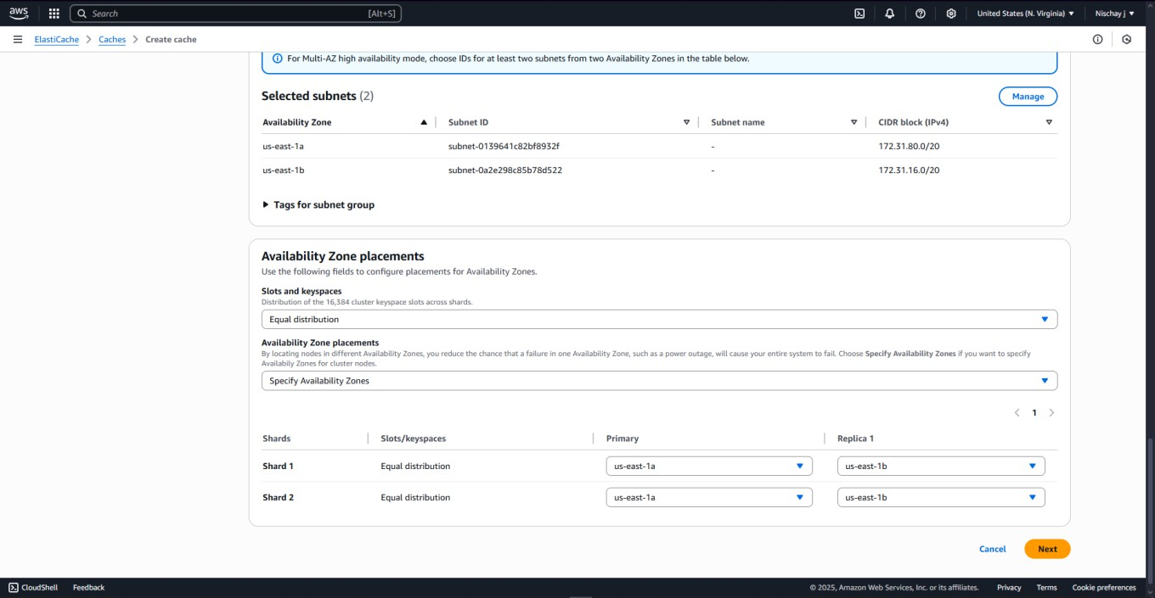

**Step 11:** Open a new tab and open EC2.

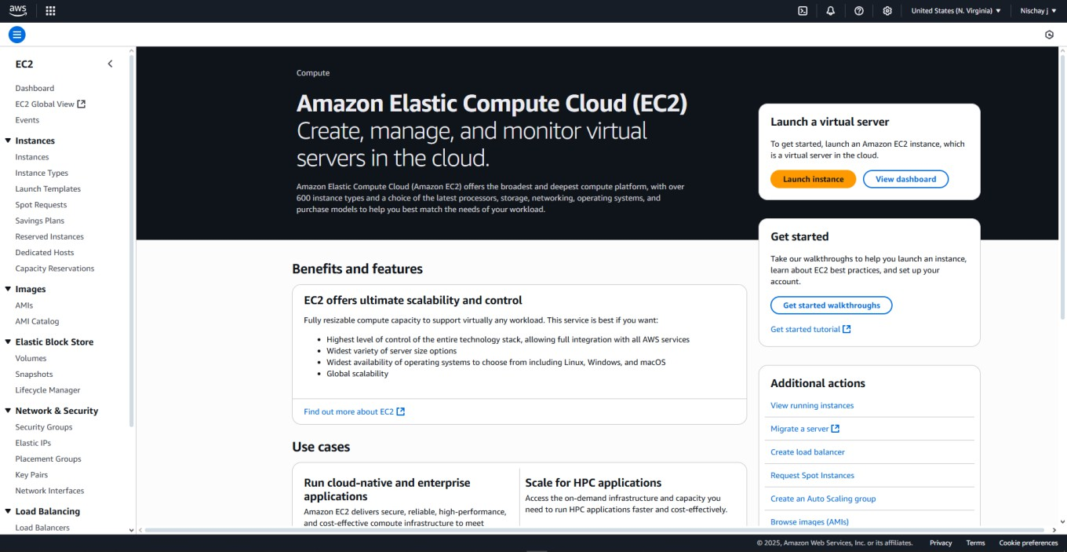

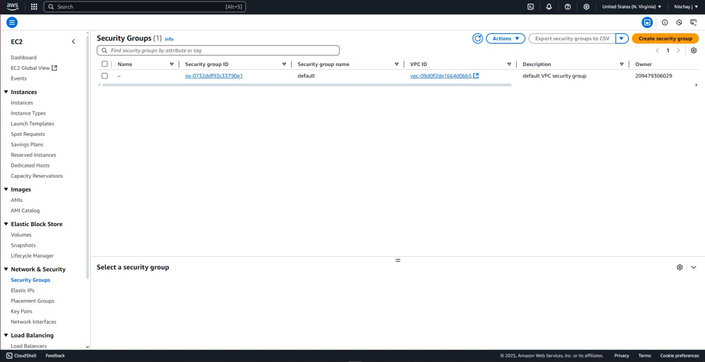**Step 12:** On the left side of the screen click on ‘Security Groups’ and click on ‘create security Groups’.

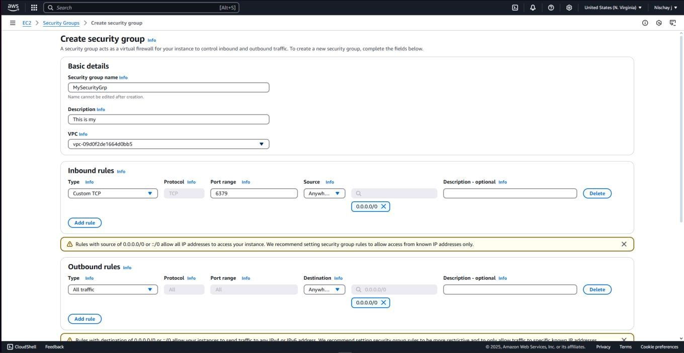**Step 13:** Fill the name, port range as ‘6379’ and source as ‘Anywhere IP4v’.

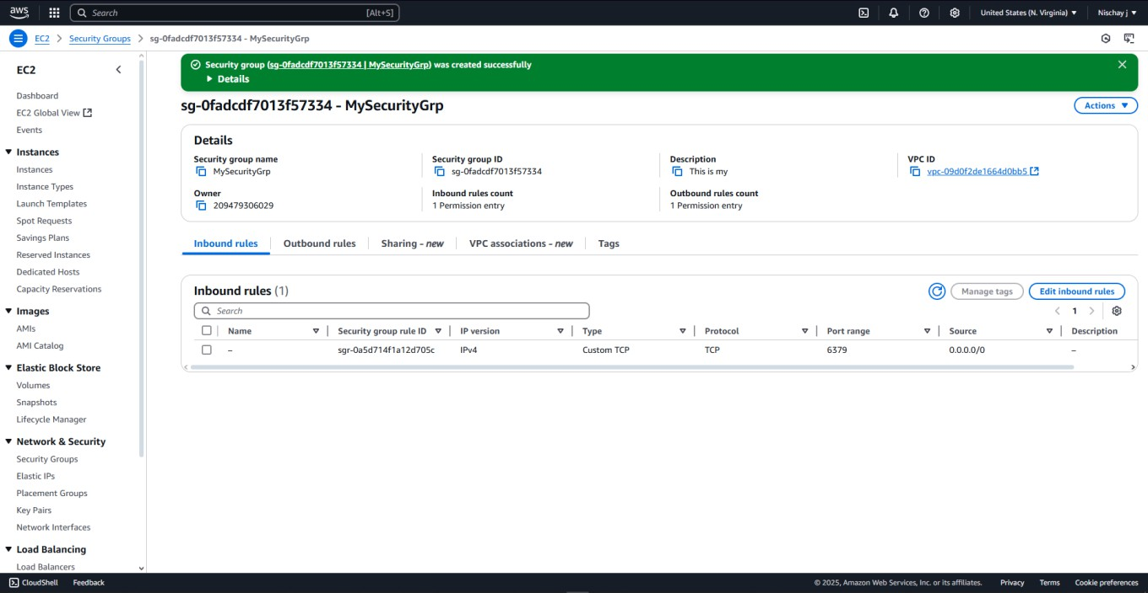**Step 14:** Security group has been created successfully.

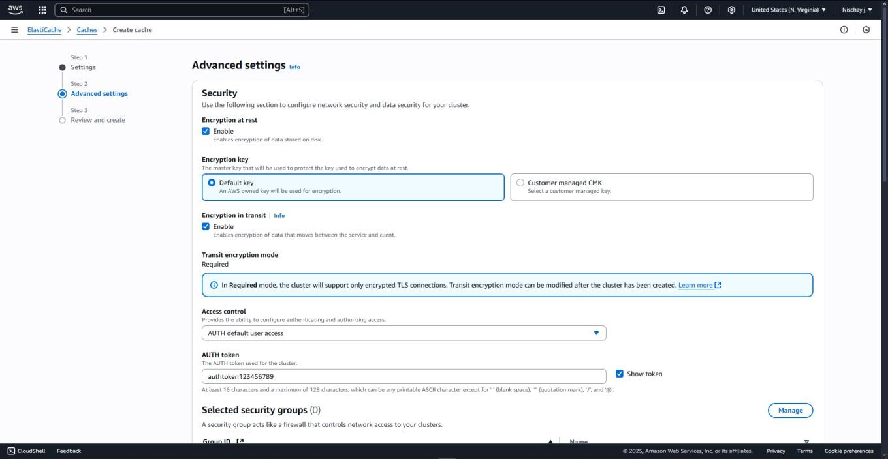**Step 15:** Now come back to the ElasticCache, select ‘AUTH default user access’ in Access control and enter the ‘AUTH token’.

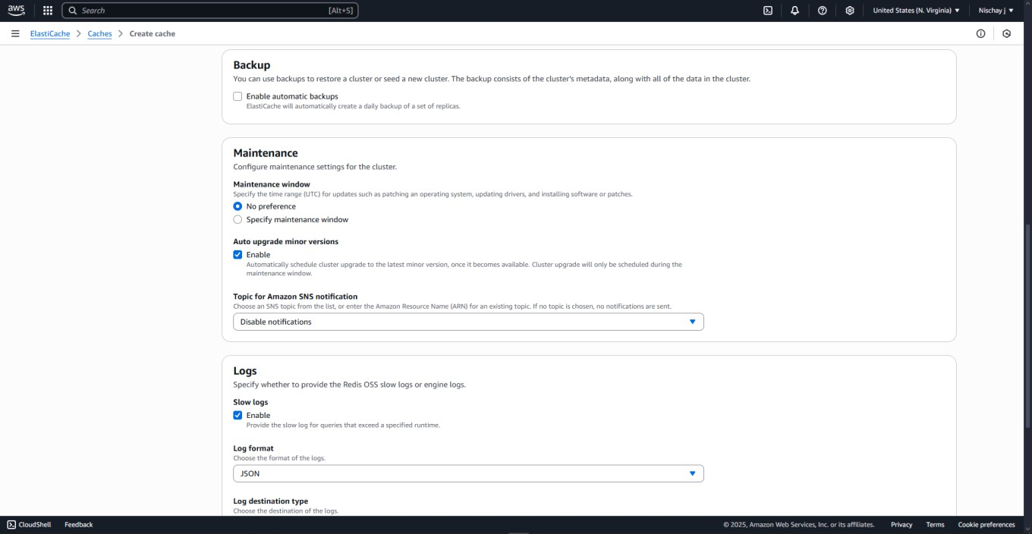**Step 16:** Disable the ‘Backup’ and enable ‘slow logs’.

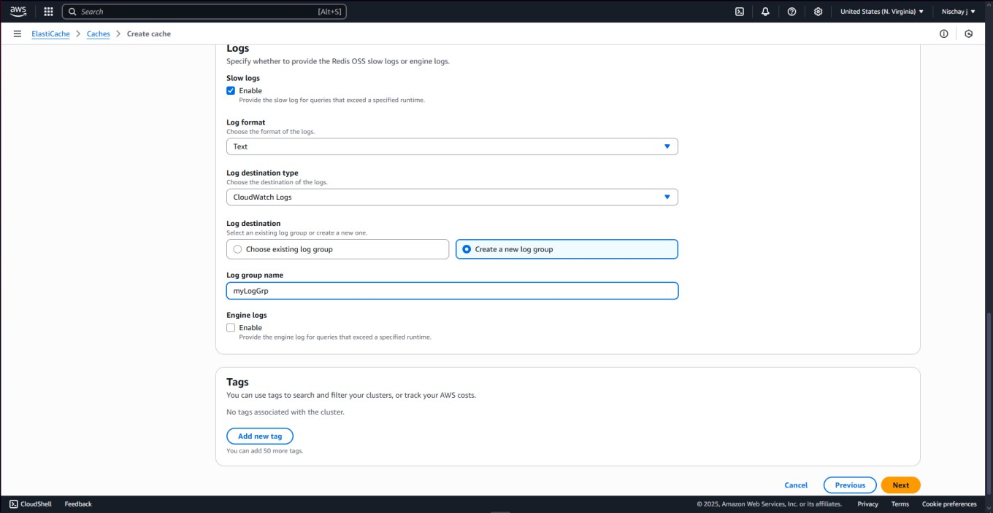**Step 17:** Select ‘Text’ for the Log format, click on ‘Create a new log group’ and then enter the log group name.

**Step 18:** Click on ‘Create’ to create a cluster.

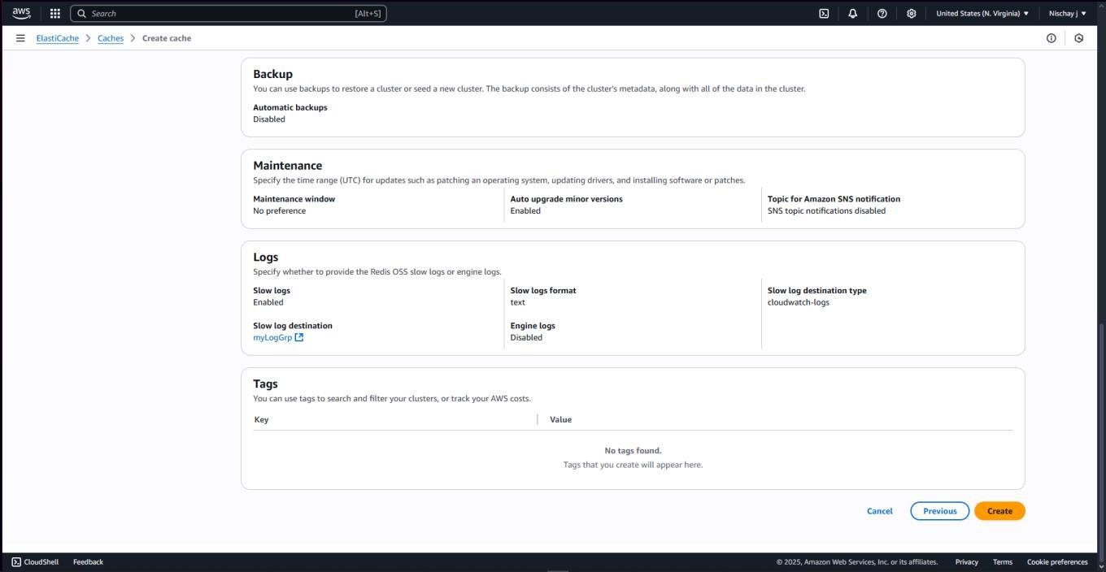

**Step 19:** Cluster has been created successfully.

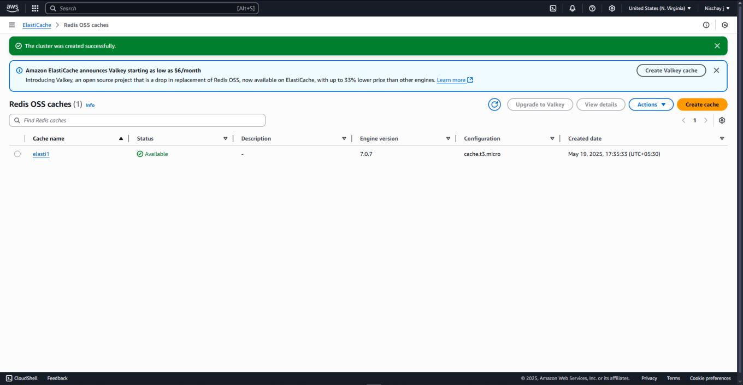

# Steps for Deletion of Cluster:

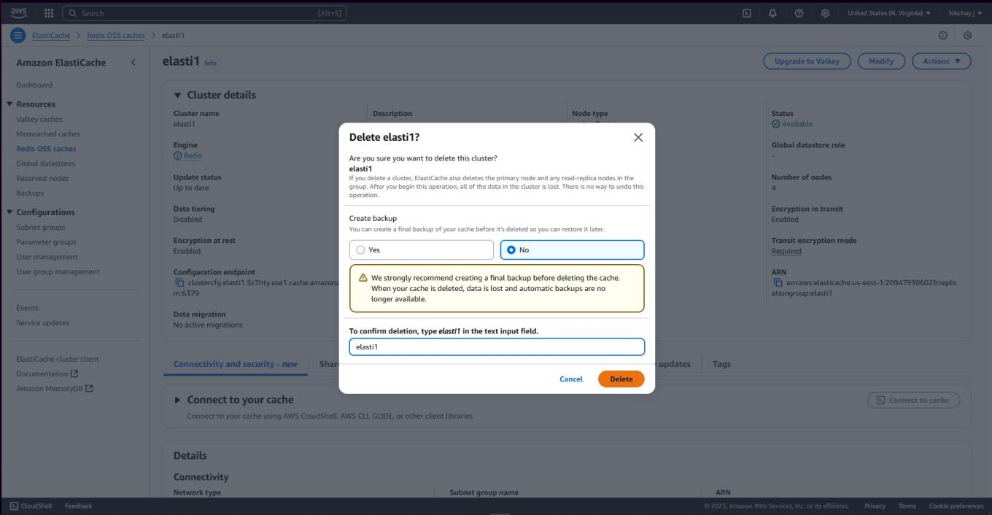**Step 1:** Select the cluster been created and click on ‘Actions’ and the click on ‘Delete’.

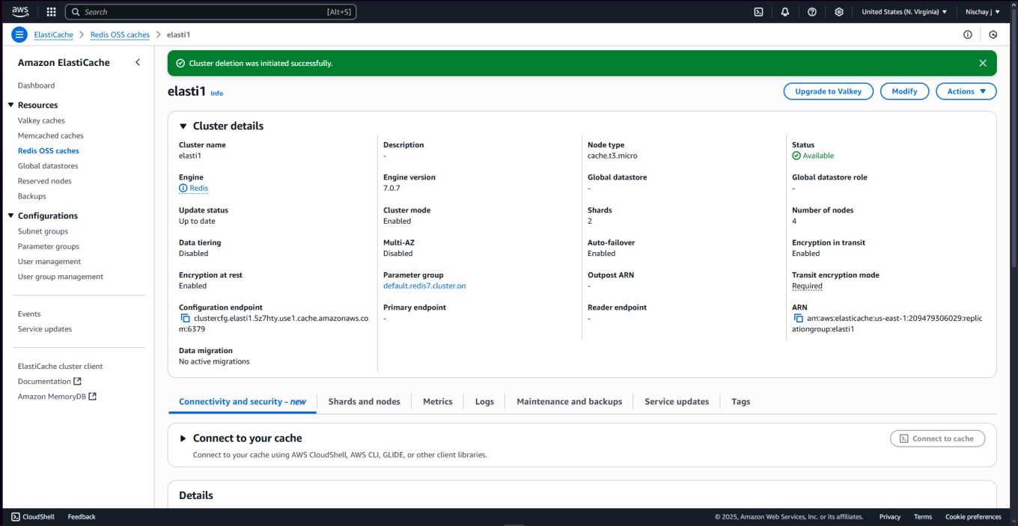**Step 2:** The cluster been created has been successfully deleted.